**Keynote Presentations**

**Perry den Brok**

**Educational Innovations in Higher Engineering Education: A Brief Overview**

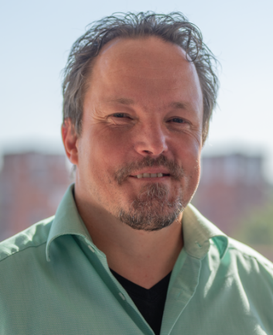Perry den Brok is full professor in Education and Learning Sciences (ELS) and chair of the group with the same name at Wageningen University. He was one of the founders of the 4TU Centre for Engineering Education, was Eindhoven leader of the Centre between 2014 and 2018, and was overall chair/director of 4TU.CEE between 2018 and 2023. Apart from teaching in the teacher education programme of WU and supervising PhD and MSc students with their theses, Perry conducts research on topics relating to educational innovation in higher education, teacher learning and professional development in both secondary and higher education, and learning environments. He has written extensively about these topics, either in handbooks, journals or more professional outlets. He is also a member of the WU Education Innovation Board, and was former chair of the division of Higher Education of the VOR (Netherlands Educational Research Association).

In his lecture on June 25, Perry will provide an overview of educational innovations in higher education, and more in particular in higher engineering education. He will briefly touch upon the most pressing reasons for universities to innovate, then proceed to provide an overview of current (and future) innovations, using the framework of educational ecosystems. During his presentation, he will also show how 4TU.CEE contributes to innovations in engineering education in the Netherlands, both with its larger (PhD) projects and the smaller innovation fund type of projects.

**Mieke Boon**

**How Philosophical and Pedagogical Challenges are Shaping Interdisciplinary Education for Responsible Innovation**

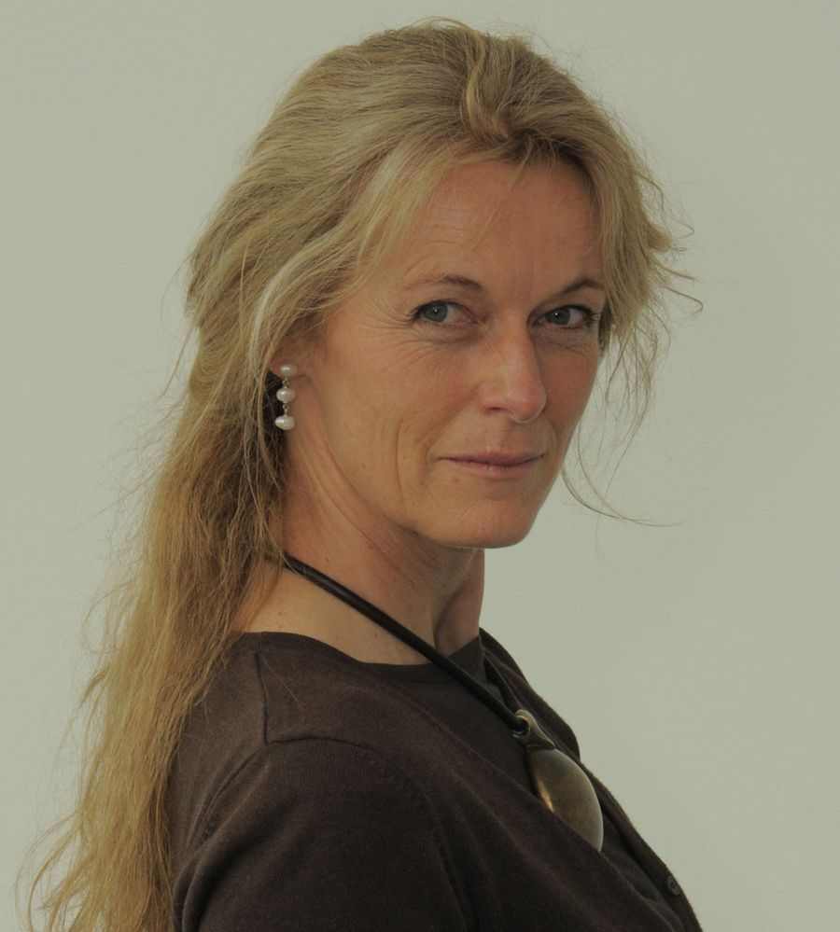Prof. dr. ir. Mieke Boon is a full professor of Philosophy of Science in Practice. Following a successful career in chemical engineering research focused on sustainable technology, her philosophical work is driven by a central question: how can academic research better connect with real-world issues to achieve meaningful societal impact? In addressing this question, she has conducted fundamental and innovative research on themes such as paradigms of science, the epistemology of science, and interdisciplinarity. She has introduced original concepts, including models as epistemic tools, conceptual modeling as a scientific method, and epistemological responsibility. Her contributions have helped shape the emerging international movement of Philosophy of Science in Practice, which she founded in 2006. One of her guiding principles in this movement is: “bringing the human back into science.” In parallel, Prof. Boon has spent the past two decades translating these philosophical insights into educational practice. She has played a key role in developing project-based and challenge-based learning (PjBL and CBL) within bachelor’s, master’s, minor, and honours programs, as well as at University College Twente. Her focus lies on the epistemological, ethical, and cognitive challenges of applying scientific knowledge to complex, real-world problems—challenges that often require interdisciplinary approaches. Most recently, she founded Stichting HOOP – Brug tussen Universiteit en Samenleving to ensure that her innovative ideas and her expertise in training and supporting multidisciplinary teams interdisciplinary research for societal impact, are made accessible beyond the university context.

In her keynote lecture, she will explore the innovative design and implementation of the Intelligence, Creativity, and Responsible Technological Innovations in Societal Transformations (ICR&TIST) minor at the University of Twente, a 30 ECTS challenge-based learning (CBL) program focused on interdisciplinary and transdisciplinary research. The minor's overarching learning objective is to equip students with the skills to tackle complex societal challenges through responsible, innovative solutions—skills that span personal, professional, and academic domains. In this session, she will dive into the collaborative design process, where a multidisciplinary team of educators worked together to shape an educational experience that fosters these crucial research skills. Through concrete examples, she will showcase how the program promotes the development of interdisciplinary research capabilities, highlighting our unique approach to curriculum development and teaching. The lecture will also touch on the philosophical underpinnings and pedagogical principles that guided this educational innovation. Finally, she will reflect on the role of teachers in this evolving educational paradigm, discussing what such interdisciplinary education demands from educators and how we, as teachers, can better support students in mastering the complex, transdisciplinary skills necessary for the challenges of tomorrow. This session promises insights into the future of engineering education and the evolving role of interdisciplinarity in shaping responsible technological innovation.

**Poster Presentations**

**Richard Pretorius**

**Great Expectations: A systemic Perspective on Aligning Expectations among Stakeholders in Challenge-Based Learning Projects**

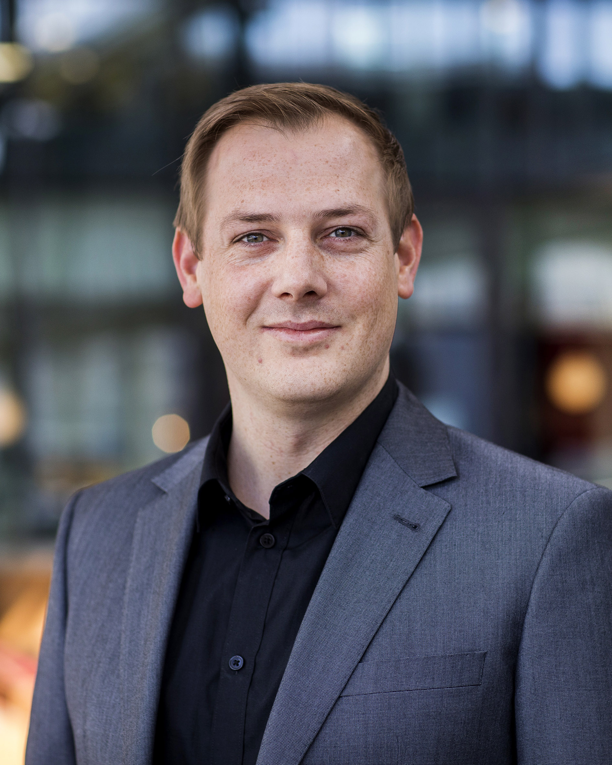Richard Pretorius is a postdoctoral researcher in the Industrial Engineering and Innovation Sciences department at Eindhoven University of Technology. Richard holds a MTh in Systematic Theology and a PhD in Industrial Engineering earned at Stellenbosch University and Eindhoven University of Technology respectively. Richard’s research focuses on the logical and philosophical underpinnings of complex systems, drawing on the theoretical contributions of Niklas Luhmann, Edmund Husserl and George Spencer-Brown and applying learnings both conceptually and empirically to organizations, innovation ecosystems, and broader societal systems.

**Anke Swanenberg**

**Rethinking Assessment: Paradigm Shift Needed for Transdisciplinary Learning**

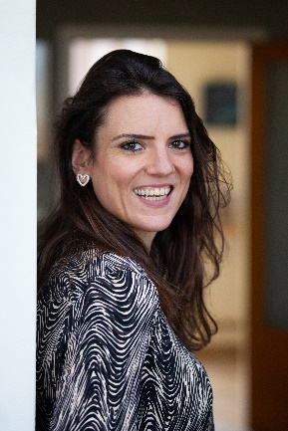Anke Swanenberg is an educational advisor and PhD-candidate at Wageningen University and Research, exploring how assessment can better support student learning in transdisciplinary education. In today’s world, students are increasingly engaged in tackling complex, open-ended challenges—like sustainability, global health, and social inequality—that require collaborative, real-world problem-solving beyond academic boundaries. Transdisciplinary learning involves navigating wicked problems, integrating diverse forms of knowledge, and co-creating solutions with societal stakeholders. However, the traditional positivist paradigm of assessment falls short in capturing and guiding this dynamic and unpredictable learning process.

This leads to the following research question: How can the defining characteristics of transdisciplinary learning drive a necessary paradigm shift in conceptions of assessment, and what design considerations emerge from this shift to support educators while honoring the unpredictability of student learning? Using educational design research, her project tries to answer this question in three iterative phases:

* **Preliminary research** through literature review and case studies to map key elements and current practices;
* **Prototyping the assessment framework** in co-creation sessions with students, educators, and societal partners;
* **Assessment of the framework**’s relevance and usability through a mixed-method evaluation involving surveys and thematic analysis.

The aim is to develop a practically useful, theoretically grounded framework that supports assessment as a meaningful and adaptive learning process in transdisciplinary settings.

**Miriam Losse**

**Challenges of Interdisciplinary Education with Social, Medical and Technical Disciplines**

Afbeelding met Menselijk gezicht, persoon, kleding, glimlach

Door AI gegenereerde inhoud is mogelijk onjuist.Miriam Losse works at Saxion, University of Applied Sciences as a Senior Advisor Research & Education, with broad methodological experience in the different disciplines of higher vocational education. She is also a PhD candidate in the Department of Philosophy at the University of Twente. Her PhD research focuses on effective knowledge use in interdisciplinary collaboration of students in professional practices.

At Saxion University of Applied Sciences (UAS), students are educated to become a professional in different vocational practices. These practices vary within a broad range of vocations or disciplines, like: nursing, business administration, engineering, teaching, medical laboratory work or legal advice. In most of these practices, professionals don’t do research as a separate project. However, they should be able to deploy research activities that serve their daily professional tasks in their practical context.

Students in UAS’s are supposed to be trained for: A. Finding and using existing knowledge and state of the art, B. Collecting contextual data to define issue & goal, and find, test, implement & evaluate a solution. So, research activities are very much about everyday decision making, professional action and solving practical problems. In the end, this type of research leads to situational knowledge that meets the requirements of those involved.

As issues in professional practices become more complex, professionals from different educational backgrounds (disciplines) have to work together in problem solving. In these interdisciplinary (ID) collaborations they meet different implicit theoretical frameworks, different approaches for problem solving and different research approaches. A good recipe for misunderstanding, conflict, and inefficient use of each other’s knowledge. Therefore, Saxion facilitates an interdisciplinary semester with real life assignments, in which over 1000 students from 27 educations participate in project groups, that cover the domains of Technique & Life science, Health and Wellbeing and Business & Law. Although a lot of nice solutions are elaborated every semester, the goal of ID knowledge use for finding common ground and combining knowledge for elaborating a solution often is not achieved. Since 2023, the ID-semester has set goals for supportive education, in which students actively change perspectives and get to know about each other’s knowledge base and research approaches.

Miriam’s poster is about some challenges that have been revealed in the new approach of the ID-semester. How can we understand the ID-challenges from an epistemic point of view?

# Henk-Jan van den Brink

**Interdisciplinarity in Chemical Engineering for Sustainability**

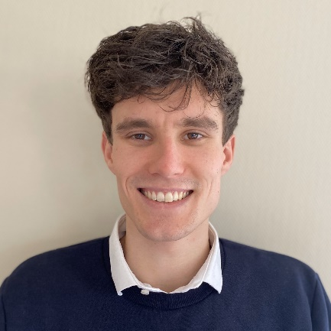Henk-Jan van den Brink is a PhD candidate in the Philosophy department at the University of Twente, investigating interdisciplinarity in chemical engineering. As a chemical engineer who also studied philosophy, he is interested in how scientists from different backgrounds can effectively collaborate to contribute to sustainable technology. Specifically, he wants to answer questions such as: What and how are concepts, models and methods being used from each of these domains? What is the nature and result of their interaction?  What are the cognitive hurdles the researchers meet in these interactions?

Chemical engineering is an established discipline, studying this discipline can provide further understanding of integration of different scientific domains. His direct involvement in a European pathfinder consortium, allows detailed data collection and analysis of interdisciplinarity in scientific practice through an ethnographic method. This work can help challenge academic notions of integration and unpack this multi-dimensional notion in the context of chemistry and chemical engineering. The insights he gains are likely to be valuable for science management, funding, as well as education.