

TERM SHEET

[NAME COMPANY]

Between

[Name(s)]

[University]

[Holding]

 |  | 
What do you get?  Type of IP / title / name / reference number / rights granted |  | What do we get?  Equity share:  [X]% university holding  [X]% founding team  [Optional] [X]% royalty fee and [X]% sublicence fee, combined with an annual fixed fee.

How is this deal made?
This deal is made based on university standards. It is aligned with the deal terms and is further elaborated in other documents: 4TU standard documentation for IP licences and capital waters shareholders’ agreement

Agreement between

 | PARTY 1 |  | PARTY 2 |  | PARTY 3
 | [Name founder]  [email address] |  | [Name founder]  [email address] |  | [Name founder]  [email address]

 | PARTY 4 |  | PARTY 5
 | [Holding]  [optional extra info] |  | [University]  [optional extra info]

The contents of this agreement

 |  |  |  |  |  | 
The Agreement |  | Knowledge Transfer |  | Milestones |  | Share Structure
We introduce the key parties to this agreement and explain the purpose of this term sheet in simple terms. |  | We explain what intellectual property the university contributes, how you'll get access to it, and the conditions for transitioning from a license to ownership of this valuable knowledge. |  | We define the specific business targets you need to hit to demonstrate commercial viability, and the timeframe for achieving them. |  | We outline how the company's shares will be distributed at incorporation, explain the vesting schedule for founders, and clarify what happens if a founder leaves the company.

 |  |  |  |  |  | 
Founder Commitments |  | The Process |  | Important Context |  | Legal Details
We detail the specific commitments founders must make to the company, particularly regarding time investment, and explain why these commitments are crucial for the company's success. |  | We outline what happens after this term sheet is signed, including the incorporation process, subsequent agreements, and practical next steps. |  | We explain several important contextual factors and regulations that affect this agreement, including legal requirements, state aid rules, and university policies. |  | We cover several important but general provisions that govern how parties communicate about the agreement, how costs are shared, and which laws apply.

The Agreement

In this section: We introduce the key parties to this agreement and explain the purpose of this term sheet in simple terms.

- What is this document?
This term sheet outlines the key terms and conditions for establishing a spin-off company based on technology developed at the university. It serves as the foundation for more detailed agreements that will follow. This arrangement follows standard principles as outlined in the National IP Deal Term Principles document published by Universities of the Netherlands.

- Who are the parties involved?
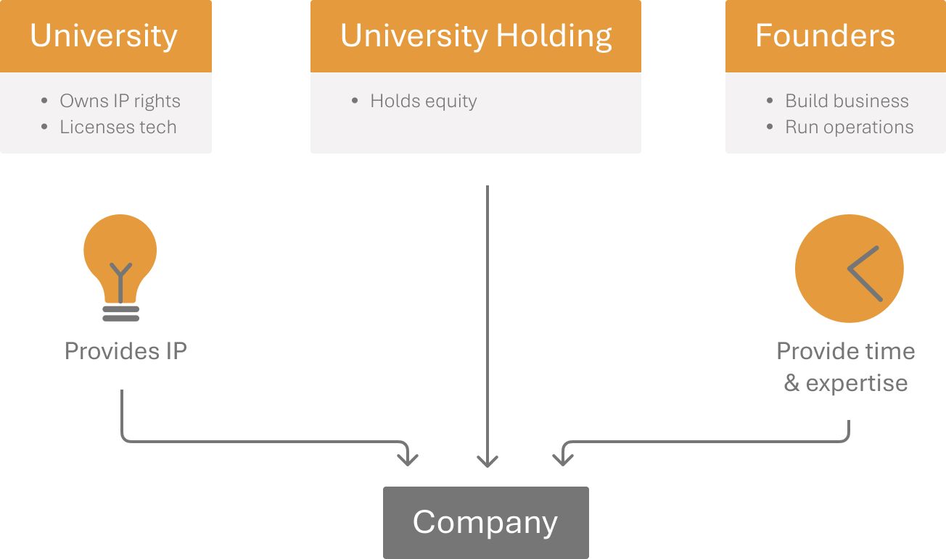
The Founders:
[Name] - [Brief role description and optional role in board]
[Name] - [Brief role description and optional role in board]

The University:
[University Name] - The public institution where the intellectual property was developed.

University Holding:
[University Holding Name] - The participation company through which the university participates in spin-off companies.

- What is the purpose of this collaboration?
The parties wish to establish a new company that will further develop and commercialize technology created at the university. The business of the company will be [business description]. This arrangement follows standard Spin-off deal term principles: the university contributes intellectual property, the university holding receives shares, and the founders contribute their time and expertise.

- Is this term sheet legally binding?
This term sheet serves two purposes:
- Statement of intention: It outlines the parties' intention to incorporate a company under the terms and conditions stated here.
- Partially binding agreement: After signing but before incorporation, only the confidentiality, communication, costs, and dispute resolution provisions (under "Important context & regulations" and "Legal details") are legally binding.

- When does the full agreement become binding?
The terms and conditions will automatically become binding upon incorporation of the company, except for provisions that will be replaced by the definitive agreements.

- Can I still decide not to proceed after reviewing this term sheet?
Yes. Each party explicitly acknowledges that before signing this term sheet, they have the right to withhold final approval at their sole discretion. This would result in termination of negotiations between the parties.
In such a case, none of the parties shall have any claim for damages or for continuation of negotiations.

What this means for you: This term sheet is designed to create a fair and transparent framework for collaboration between founders and the university and the university holding. It balances the interests of all parties while maximizing the chances of successfully bringing university technology to market.

Knowledge transfer

In this section: We explain what intellectual property the university contributes, how you'll get access to it, and the conditions for transitioning from a conditional license to ownership or a continued license.

- What does the university contribute and how will the university be compensated?
The university owns intellectual property rights necessary for the company. These consist of [specific patents/software/technology] developed at the faculty of [name] and form the foundation for the company. It is listed in Annex 1.

- How is the distribution of equity determined?
The university holding's equity stake is determined according to standardized Spin-off deal term principles. You can find this in the National IP Deal Term Principles .

- How do you gain access to this IP?
The company will receive a royalty-free, exclusive license to the patent(s) listed in Annex 1. during the milestone period. This means that only your company may use these rights.

[Optional, in case of software and/or IP related technology:] The company receives a royalty-free, non-exclusive license to the software and/or IP related technology during the milestone period. This means that your company may use the software and/or IP related technology on a non-exclusive basis.

At all times, the university remains the right to use the intellectual property rights for educational and research purposes, including national and European funded research project.
Note: Is the IP more broadly applicable than just for your company? Then the exclusivity applies only to your specific field of use: [description of field of use].

Note: In a hybrid equity deal, the university also receives a royalty and sublicence fee.
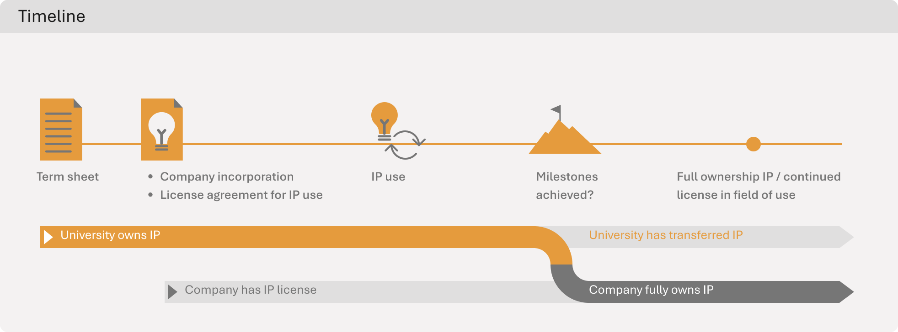

- What about patent maintenance and costs?
Your company will have input on all aspects of the application, maintenance, and enforcement of the patent(s) while you hold the exclusive license.
All out-of-pocket costs incurred by the university related to filing, maintaining, and upholding the patent(s) (the "Historical Costs") must be reimbursed by your company upon completion of the milestones or the Milestone Period. These costs cover the first 30 months from the initial filing date, including the priority filing and subsequent PCT filing.
Any IP protection costs after this 30-month period, costs related to national phase applications, transfer costs, and all costs after transfer will be your company's responsibility.
Note: As the license is non-exclusive and limited to your Field of Use, these costs may be shared (retrospectively) if other licenses are granted.
Note: Article 10 applies only when the intellectual property rights involve patents, as their validity depends on proper management and timely payment of fees.

What this means for you: You can start building your business using the university's technology right away under an exclusive license. If your company succeeds in meeting its goals within the agreed timeframe, you can become the full owner of (or receive a continued license to use) the patent(s) by paying only the historical protection costs. This staged approach minimizes your initial risk while providing a clear path to full ownership as your business grows.

Milestones

In this section: We define the specific business targets you need to hit to demonstrate commercial viability, and the timeframe for achieving them.

- What milestones must you achieve?
The agreed milestones are:
- Net sales amounting to at least EUR 500,000, not including grants and subsidies OR
- Venture capital or other equity investment of at least EUR 500,000
(This does not include convertible loans and similar instruments.)
- [Optional: Technology milestone (e.g., certification, regulatory approval, prototype completion)]

For clarity: when such instruments convert into equity, they do count as equity investment.
Note: These milestones are based on the Spin-off deal term principles.

- What happens when you achieve the milestones?
If your company reaches the agreed milestones within the Milestone Period, this proves it is successful in the early development phase. You will then have the option to acquire ownership of or a continued license to use the intellectual property rights for no additional purchase price beyond reimbursement of the Historical Costs.
Note: For broadly applicable IP and software, the exclusive license will be continued instead of full transfer.

- What if you don’t achieve the milestones?
If your company fails to meet the milestones within the Milestone Period, upon written notice from the university, the university will review the relevant milestone and may agree on a new deadline. If this adjusted deadline is also not met, the university may, at its discretion, terminate the license.

- What is the timeframe?
The "Milestone Period" is 36 months after the date of signing the IP License Agreement. This is the window of time you have to achieve the milestones above.
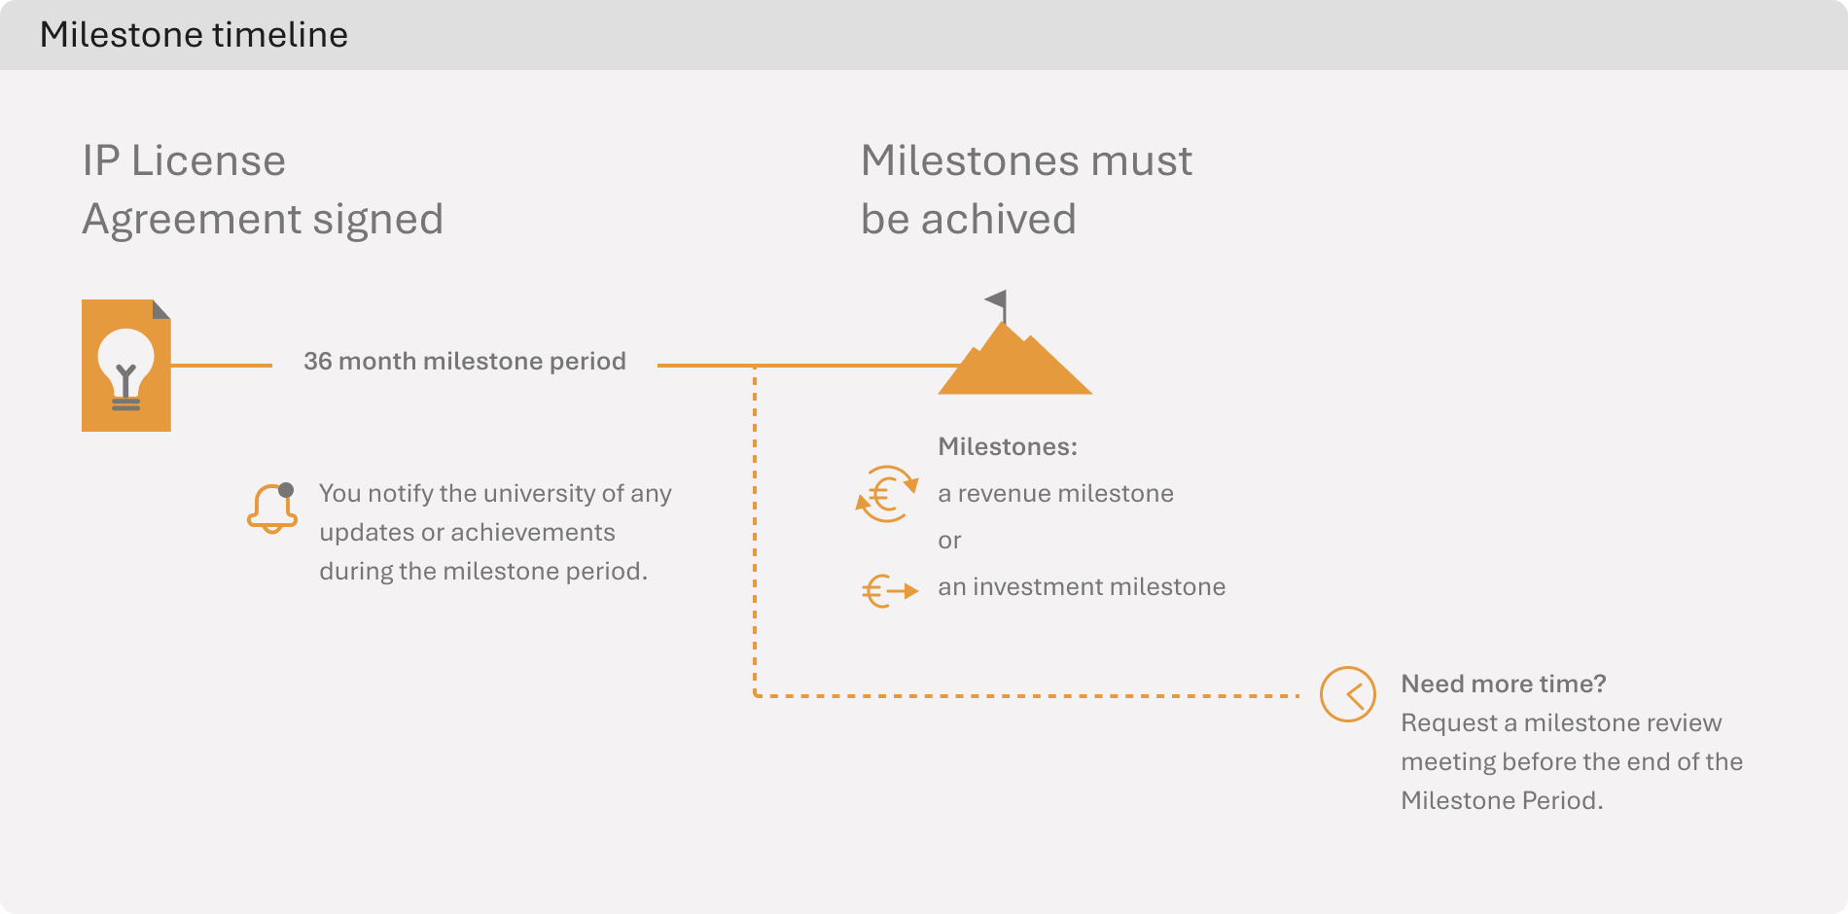

- Why these specific milestones?
These milestones were carefully selected to demonstrate that your business has achieved either:
- Commercial traction with real customers (revenue milestone), or
- Significant validation from professional investors (investment milestone)
Either achievement indicates your business has progressed beyond the initial concept stage and is recognized as having genuine market potential.

- When and how will milestone achievement be assessed?
You'll need to provide the university with regular updates on your progress toward these milestones. When you believe you've achieved a milestone, you should notify the university and provide documentation confirming the achievement.

- What if we need more time?
We understand that startups often need to pivot or face unexpected challenges. If circumstances change, you can request a milestone review meeting before the end of the Milestone Period to discuss potential adjustments to either the targets or timeframe.

What this means for you: These milestones give you clear targets to work toward within a specific timeframe. They're designed to be challenging but attainable with focused effort. The milestone framework is meant to create alignment between your business goals and the university's expectations, ensuring all parties are working toward the same definition of success.

Share structure and ownership

In this section: We outline how the company's shares will be distributed at incorporation, explain the vesting schedule for founders, and clarify what happens if a founder leaves the company.

- How will shares be distributed initially?
At incorporation, the company's shares will be distributed as follows:
Initial Share Distribution

Shareholder | Percentage | Number of shares
Founder 1 | [X] % | [X]
Founder 2 | [X] % | [X]
University Holding | [X] % | [X]
Total | 100% | [X]

All shares are common shares with a nominal value of EUR 0.01.

- Why is the university holding’s stake protected from
dilution initially?
The university holding's share percentage reflects the value of the intellectual property rights being contributed to the company. This percentage will not be affected by changes in or additions to the team until the milestones are reached. This ensures the university holding receives fair value for its contribution while your team builds the capability to reach the milestones.

- How does the vesting schedule work?
The shares held by founders are subject to a vesting schedule over 4 years with a one-year cliff year and a 4-year lock-up period.
Vesting means that your full ownership rights to these shares build up gradually over time as you contribute to the company's development.
This protects all shareholders by ensuring that people who remain committed to building the company long-term receive a fair share of its value.

Note: If you leave within 1 year (the cliff year) you have to give back all your shares to the company. If you leave within 4 years, you have to give back part of your shares. After the first year 25% of the shares vest, with the remaining shares vesting monthly over the following 3 years. If you leave voluntarily within the lock-up period 50% of the vested shares are considered unvested. This is further outlined in the Shareholders’ Agreement.

- What happens if a founder leaves?
The consequences of a founder leaving are specified in the Shareholders' Agreement.

- How will future investments affect ownership?
As the company raises additional investment, all shareholders' percentages will likely be diluted. This is a normal part of growth. The university holding will be subject to the same dilution as other shareholders.

What this means for you: This ownership structure balances the interests of active founders with those of the university holding. The vesting schedule encourages long-term commitment while providing protection if the founding team changes. Understanding these arrangements upfront helps avoid conflict later as the company evolves and grows.

Founder commitments

In this section: We detail the specific commitments founders must make to the company, particularly regarding time investment, and explain why these commitments are crucial for the company's success.

- What time commitment is expected from founders?
As a founder, you commit to investing your time, effort, and expertise to build the company and achieve the milestones. The specific expectations vary by role:
- Founders: [Full-time] commitment ([1.0] FTE)
- Advisors: Minimum commitment of [X] FTE.

Note: if the advisor is/remains active within the university, specific approval needs to be granted for these ancillary activities.

- Why is time commitment so important?
Your active involvement is essential for three key reasons:
- Your expertise is needed to develop the technology from academic concept to commercial product
- Future investors will evaluate the team's commitment when making investment decisions
- The university's contribution of intellectual property rights is made with the expectation of active commercialization.

- What happens if founders cannot meet these commitments?
If circumstances change and you cannot maintain your agreed level of commitment, you should promptly inform the other shareholders. This may trigger discussions about your continued role and equity position in the company, as outlined in the leaver provisions.

What this means for you: Your active participation is the engine that drives the company's success. These commitments ensure all parties have clear expectations about your involvement. The university is investing valuable intellectual property with the expectation that you will commit the time and effort needed to transform it into a successful business.

Process: from signing to incorporation

In this section: We outline the exact sequence of steps that will happen after this term sheet is signed, including incorporation, follow-up agreements, and practical administrative actions.

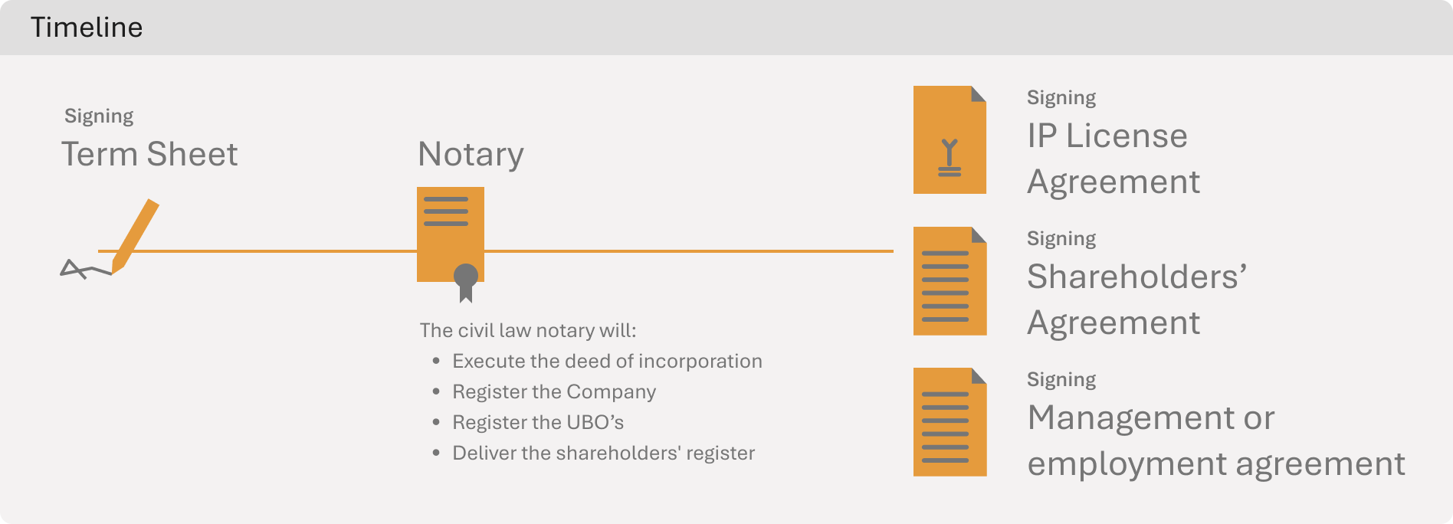

- What happens right after signing this term sheet?
After signing this term sheet, the Founders and University Holding will instruct a civil-law notary to prepare for company incorporation.

- What happens at closing?
At closing, the notary will:
- Execute the deed of incorporation of the Company
- Register the Company and its management board with the Dutch trade register
- Register the Ultimate Beneficial Owner(s) (UBO) with the UBO register
- Deliver the shareholders' register to the Company

and the parties will execute the following definitive agreements:
- the Shareholders' Agreement
- the IP License Agreement(s)
- management/employment agreement(s)
These documents will expand upon the principles established in this term sheet.

What this means for you: Understanding this process helps you prepare for the practicalities of launching your company. Each step has been designed to establish the proper legal foundation for your business while protecting the interests of all parties.

Important context & regulations

In this section: We explain several important contextual factors and regulations that affect this agreement, including legal requirements, state aid rules, and university policies.

- What is the Vifo Act and why does it matter?
The licensing or transfer of intellectual property rights may classify as a “verwervingsactiviteit” under the Act on the security screening of investments, mergers and acquisitions (Vifo Act). If this is the case the university and your company might need to file a notification with the Bureau Toetsing Investeringen (BTI). This screening is a security measure for certain types of technology transfers.

- How do state aid rules affect this agreement?
The intellectual property rights were developed with public funding. European regulations require that the university enter into market-conforming agreements when commercializing such assets.
Note: This ensures fair competition and prevents improper subsidization of private companies. The Spin-off deal term principles established by Universities of the Netherlands guide this process, ensuring compliance while supporting innovation.

- How does the university distribute its returns internally?
Future profits on [amount] university holding's shares [optional in case of a hybrid deal: and received royalties and sublicense fees] (which represent the university's contribution of intellectual property rights) will be divided according to the university's applicable 1/3 regulations:
[Brief description of the distribution formula]
This internal policy ensures appropriate recognition and reward for the inventors and departments that created the intellectual property.

What this means for you: These contextual factors may seem bureaucratic, but they provide important protections and ensure compliance with laws and regulations. The university has structured this agreement to navigate these requirements while maximizing your company's chances of success.

Legal details

In this section: We cover several important but general provisions that govern how parties communicate about the agreement, how costs are shared, and which laws apply.

- How is confidentiality handled?
None of the parties may disclose information concerning this term sheet without the prior written approval of the other parties, except as necessary to execute the provisions or as required by law.

- What can be communicated publicly?
Parties may make public statements regarding their cooperation without disclosing the specific terms and conditions of this agreement.

- Who pays for what?
Each party bears its own costs, including advisor fees. After incorporation, the company will be fully responsible for its own expenses, including the notary costs for incorporation.

- What law governs this agreement?
This term sheet and any further agreements are exclusively governed by Dutch law. Parties will first attempt to settle any disputes amicably. If that fails, disputes will be submitted to The Hague district court.

What this means for you: These provisions create clarity around how parties will work together, communicate about their relationship, and resolve any disputes. While they may seem like standard legal clauses, they establish important ground rules for a successful partnership.

Signatures

[name founder 1] |  | [name founder 2]
[name founder 3]
[name], director |  | [name], [position]
[Name University Holding] B.V. |  | [Name University]

Signed on [Signing Date]

Annex 1 – Intellectual Property Rights

PATENT RIGHTSS

- Licensor’s patent application with application number [number] [applicable up to 12 months] OR international application number [number] [after 12 months], with priority date [date] (date of application) for “[TITLE]” and each patent that issues or reissues from this patent application, with Licensor’s internal reference number [number];

- Licensor’s patent application with application number [number] [applicable up to 12 months] OR international application number [number] [after 12 months], with priority date [date] (date of application) for “[TITLE]” and each patent that issues or reissues from this patent application, with Licensor’s internal reference number [number];

- [others].

COPYRIGHTS

- [software description]. [Optional: stored in an I-DEPOT under number [number].]

OPTIONAL: IP RELATED TECHNOLOGY
- [description of know-how, protocols, recipes, algorithms, data, in any way related to the intellectual property rights].

