4TU/14UAS template for extended abstracts – guidelines for authors

Author1_name Author1_surname ¹, Author2_name Author2_surname²

¹ Delft University of Technology, Faculty of Architecture, Department of Urbanism, 3D Geoinformation Group, Delft, The Netherlands – xxx@tudelft.nl
² InHolland University of Applied Sciences, Research and Innovation Center Engineering, Design and Computer Science, Delft, The Netherlands - yyy@inholland.nl

Keywords: Digitalisation, Artificial Intelligence, Virtual/Augmented Reality, Digital Twinning, Robotics.
Extended abstract
These guidelines are provided for the preparation of the extended abstracts submitted to the 4TU/14UAS Research Day on Digitalization of the Built Environment. These guidelines are issued to ensure a uniform style for all submitted extended abstracts.
The extended abstract must be written in English.
The title must be in Times New Roman, with a size of 14, bold, centred. You can use the style “Title” from the Styles ribbon bar in Word.
After leaving 2 blank lines, the list of author(s) (First name and family name/surname) must be in Times New Roman, with a size of 12 pts, centred. If required, numbers linking to the respective affiliations are to be added in superscript, as shown in this template. You can use style “Authors”.
After leaving one blank line, information about the affiliation(s) must be in Times New Roman, with a size of 12 pts, justified. You can use style “Affiliation”.
After leaving 3 blank lines, up to 6 keywords must be added after "Keywords:". The keywords must be in Times New Roman, with a size of 12 pts, justified. You can use the style “Normal”.
After leaving 2 blank lines, provide the extended abstract text. The extended abstract text must contain between a minimum of 2 pages and a maximum of 3 pages (including figures, tables and references). Text must be in Times New Roman, with a size of 12 pts, justified, simple line and paragraph spacing. You can use the style “Normal”. The abstract text must begin in a new line, after “Abstract”.
If applicable, references must be cited in the text, e.g. as (Agugiaro et al., 2020) for multiple authors, or as (Sebastian, 2024; Zeiler et al., 2010) for multiple citations at once, and listed in alphabetical order at the end of the document, in the “References” section. A maximum 10 references is permitted. Please refer to examples shown in the references section. To format the references in the respective section, there is the style “ReferencesItem”. Wherever possible, please add an URL to the online version of the document you are referencing.
Finally, figures (up to maximum 5, if applicable) must be placed in the text, properly separated from the preceding text by one blank line. All captions must be centred directly beneath the respective figure and must use font Times New Roman, size 12, centred. Please use style “FigureCaption”. Figures must be referenced also in the abstract text, such as, for example: Figure 1 provides an example of scenario management of urban development scenarios.

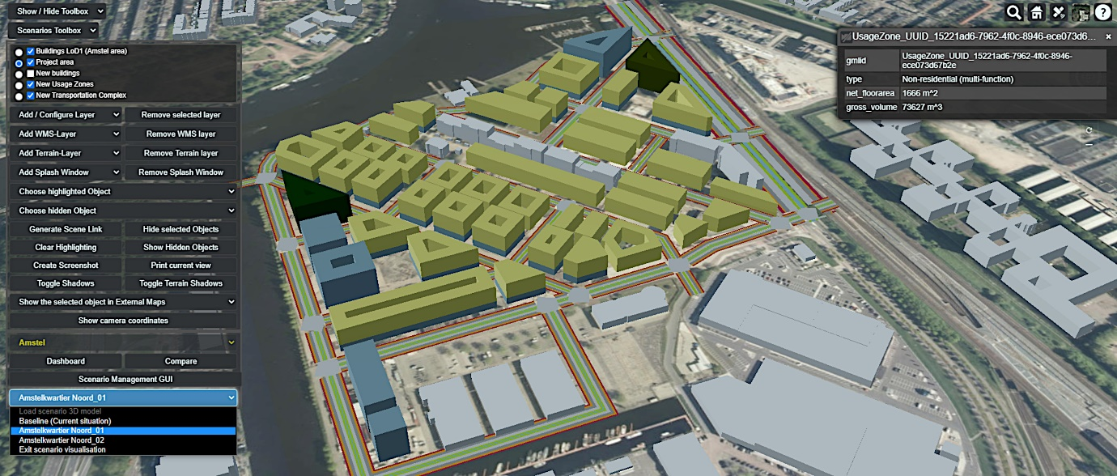
Figure 1. Example of caption for a figure, including placement and numbering. Image source: (Agugiaro et al., 2020)
All captions must be numbered consecutively, e.g. Figure 1, Figure 2, Figure 3, etc. The label must be separated from the actual caption text with one dot. After the caption, you can continue with the text of the extended abstract (if applicable).
Acknowledgements
This section is optional. It can be added only if you need to. Please use Times New Roman, with a size of 12 pts, justified, simple line and paragraph spacing. You can use the style “Normal”.
References
Please note: whenever possible, references must include the DOI
Agugiaro, G., García González, F.G., Cavallo, R., (2020). The city of tomorrow from... the data of today. ISPRS Int. Journal of Geo-Information, 2020, 9(9), 554. https://doi.org/10.3390/ijgi9090554
Sebastian, R. (2024). Sustainable Engineering of Future Urban Systems: An Inclusive Approach Toward Livable, Climate-Neutral, and Productive Smart Cities. In: Dunmade, I.S., Daramola, M.O., Iwarere, S.A. (eds) Sustainable Engineering. Green Energy and Technology. Springer, Cham. https://doi.org/10.1007/978-3-031-47215-2_18
Zeiler, W., Savanovic, P., van Houten, R., Boxem, G. (2010). Multi Criteria Decision Support for Conceptual Integral Design of Flex(eble)(en)ergy Infrastructure. In: Ehrgott, M., Naujoks, B., Stewart, T., Wallenius, J. (eds) Multiple Criteria Decision Making for Sustainable Energy and Transportation Systems. Lecture Notes in Economics and Mathematical Systems, 634. Springer, Berlin, Heidelberg. https://doi.org/10.1007/978-3-642-04045-0_4

