ALICE AND EVE: A CELEBRATION OF WOMEN IN COMPUTER SCIENCE

J.C. van Huizen
Philosophy of Science, Technology and Society
University of Twente
Enschede, The Netherlands
j.c.vanhuizen@student.utwente.nl

M. Huisman
Electrical Engineering, Mathematics and Computer Science
University of Twente
Enschede, The Netherlands

S.A.M. Lathouwers
Electrical Engineering, Mathematics and Computer Science
University of Twente
Enschede, The Netherlands

A.M. Schaafstal
Electrical Engineering, Mathematics and Computer Science
University of Twente
Enschede, The Netherlands

M.I.A. Stoelinga
Electrical Engineering, Mathematics and Computer Science
University of Twente
Enschede, The Netherlands
m.i.a.stoelinga@utwente.nl

Conference Key Areas: Diversity and Inclusiveness, Future Engineering Skills and Talent Management
Keywords: Diversity, Innovation, Role Models, Self-Efficacy

ABSTRACT
In most Western countries, women account for no more than 20% of the total population of computer science students. This is regrettably low, for it is frequently underscored that diversity is important for the development of creative solutions. Undergirding this imbalance is that, historically, computer science is mostly being remembered as a male endeavour even though women have contributed substantially to its emergence. In response, the Alice and Eve-event wishes to celebrate women in computer science. By exposing the female achievements across computer science history, aspirant female students are provided with the role models they need to confidently pursue a similar computer science path.
In order to support this rationale, the event consisted of an exhibition and a symposium. In the exhibition, attendees are made familiar with both female pioneers and with contemporary, yet leading scientists within the field. The symposium allows the attendees to interact directly with their female role models, seeing technically interesting topics being discussed. Notably, the event aimed at celebrating female achievements with pride, rather than discussing them within the shadow of their male counterparts.
In retrospect, the event has been met with critical acclaim. More specifically, attendees have praised the elucidation of female trailblazers. In light of this appraisal, the organization wishes to expand both its content and its audience. Moreover, it is believed that the Alice and Eve-event could serve as an example toward other engineering fields that are experiencing a similar gender imbalance.

- INTRODUCTION
In most Western countries, the proportion of female students enrolled in computer science courses accounts for approximately 20% of the total population of computer science students. This number is regrettable low as it is frequently underscored that diversity is one of the main ingredients in the development of creative solutions. Notably, renowned computer scientist William A. Wulf expressed his belief that “[engineering] is a profoundly creative profession”, buffeted and bounded by ‘life experiences’ [1, p. 8]. If women are not involved in this process, society is denying itself the grand benefit of their talents in addressing the world’s most pressing challenges. As such, Wulf appears to be a spiritual heir to the late philosopher John S. Mill, who already proclaimed two centuries ago that “the existing social relations between the two sexes [...] is wrong in itself, but now one of the chief hindrances to human improvement” [2, p. 1]. As it appears, his proclamation remains painfully relevant for today’s digital world.
Fortunately, efforts have been made to counter this imbalance. Among these efforts is Alice and Eve, an academic event that wishes to celebrate women in computer science. Its underlying rationale is simple yet solid: by making women familiar with the female achievements across computer science history - up until the here and now - they will find it easier to imagine themselves enlist to a similar computer science path. The purpose of this paper is to demonstrate how the event has intended to make this reasoning come into fruition.

- METHODOLOGY: SEEING IS BELIEVING
Indeed, as mentioned, the goal of Alice and Eve has been to expose how the field of computer science has been lifted to its current height equally by female contributions. Today, far too few people are aware of this. Upon mentioning computer science, that is, the first names to come to mind are Alan Turing, Edsger Dijkstra, Steve Jobs and Bill Gates. Perhaps, then, it should be of no surprise that it is primarily male students that engage with the subject. Role theory tells us that “people don’t attempt to achieve something unless they believe it can be done” [3, Section 3]. Seeing is believing, it seems. Yet, if the role models of computer science are predominantly male, those who believe they can achieve something alike will equally be predominantly male.
According to psychologist Sylvia Beyer, the ‘seeing is believing’-mechanism clearly manifests itself in the educational choices that female students have to make. Due to the low visibility of female engineers, “[women] tend to have low self-efficacy and believe they have little natural ability in male-dominated domains” [4, p. 156]. In other words, women do not believe that they would be successful in computer science courses, and, therefore, they are more likely to engage in other subjects. In the light of this observation, the main purpose of Alice and Eve is to break the unfamiliarity toward female computer scientists; to demonstrate that they, too, are successful in the field. Eventually, these women must represent the female role models to whom current and future generations of female computer science students will look up to. In accordance, it is these generations that Alice and Eve hopes to attract: to draw aspirant female students towards the beauty of computing and to keep current students attached to it. Not by virtue of fair treatment, but by virtue of improving computer science.

2.1. EXHIBITION
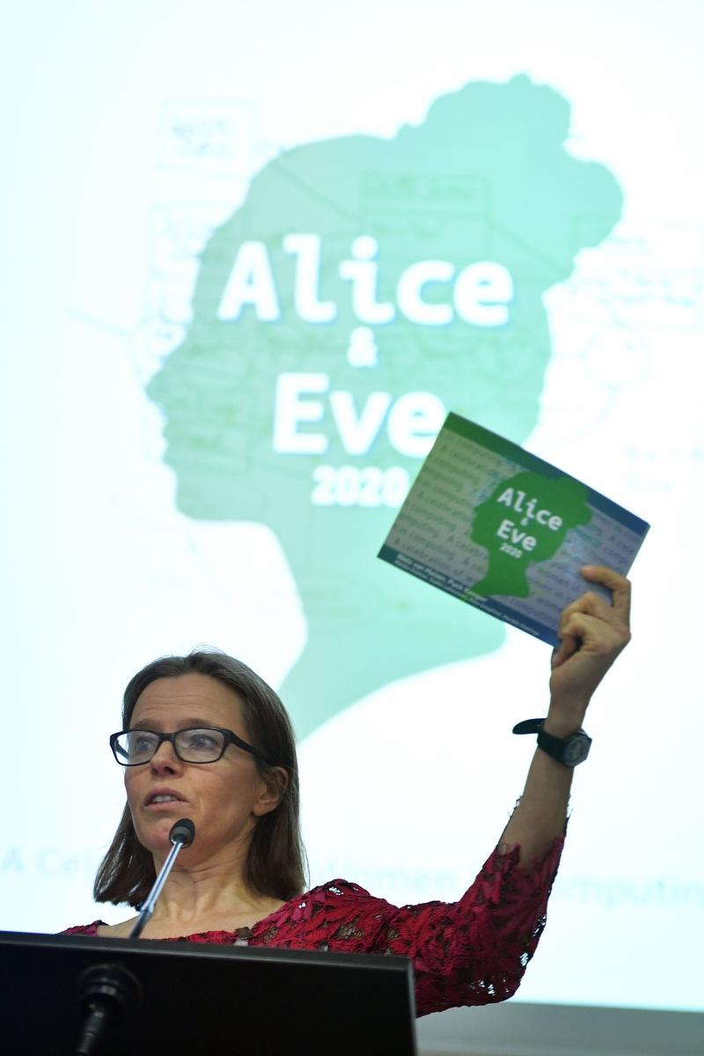
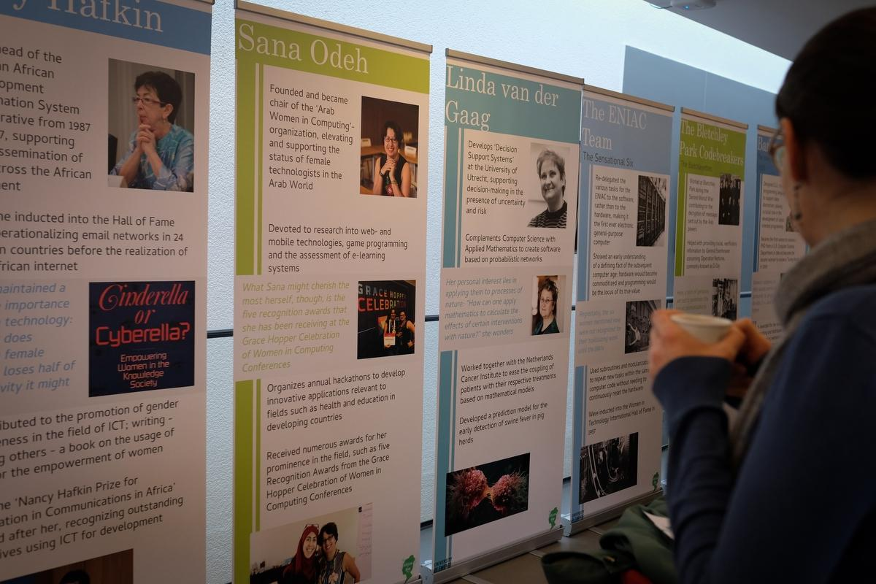
The event itself has been split into two parts: an exhibition and a one-day symposium. It is especially through the former that the event’s audience has become familiar with some of the pioneering women in computer science, such as Ada Lovelace and Margaret Hamilton. Nevertheless, the exhibition also displays women that are still very much active today; women whose contributions might not yet be widely known to the broader audience but are nonetheless of importance. Here, one must think of computer scientist Sanghamitra Bandyopadhyay, engaging in the complexity that is called evolutionary computation. Fortunately so, for, in 2014, Bandyopadhyay and her colleagues successfully identified a new genetic biomarker for breast cancer. It is especially women of the latter category that are closer to the students’ own experience, rendering it easier for them to imagine and aspire to be in a similar position.
More concretely, the exhibition has been divided into two sections: a booklet [5] telling the tales of 25 women in computer science and a picturesque banner presentation telling the same stories more visually. Notably, both the selection of women and the selection procedure have been diverse. Here, the achievements of some pioneering women were brilliantly contextualized in historian Walter Isaacson’s The Innovators [6], but the inclusion of most of the women was suggested through popular media articles. As it seems, the call for recognition is increasingly growing stronger. In the end, a list of almost 100 female computer scientists was narrowed down to a total of 25. This process was guided by the need for diversity on both a geographic level – covering different continents - and a temporal level - the 19th, 20th and 21st century. Especially related to the former, the event aims to provide role models for all female students, not only the ones originating from the Anglosphere.

2.2. SYMPOSIUM
The exhibition was first opened at the event’s one-day symposium, an intellectually rich forum inspired by the United Kingdom’s Lovelace Colloquium. At the symposium, presentations were arranged through which prominent female computer scientists could share insights from their research. Anna Sperotto, for example, elaborated on the dangers of ‘Denial of Service’-attacks. The symposium’s main objective was to demonstrate - and proudly so - what women in the field were able to achieve. As co-organizer Mariëlle Stoelinga nicely summarized: “[it] is our deliberate aim to not address gender issues within computing, but rather to show that research done by women is simply relevant, interesting and excellent” [7]. As such, the symposium provided a space in which audience members could interact directly with their female role models. Aside from these presentations, female attendees active in the field had been asked to participate in a poster presentation competition rewardable with an encouraging prize.
Importantly, it must be observed that the overall set-up of the event - including both the exhibition and the symposium - can be extrapolated to adjoining engineering fields that are experiencing a similar gender imbalance, such as electrical and civil engineering. In those fields, many female breakthroughs are as unknown as those of female computer scientists. In order to both spur enthusiasm for follow-up editions of the Alice and Eve-event and to inspire other disciplines to undertake similar initiatives, information is disseminated through a website [8] and a promotional video. On top of that, the entire event has been documented through means of photographs.

- RESULTS
Overall, the event received mostly critical acclaim from the nearly 100 attendees. As formulated on Twitter by Ph.D. candidate Judith van Stegeren, “[to] people who say “there’s just no women in computing”: you’re wrong! We’re right here, at Alice and Eve 2020. [...] We exist” [9]. On top of that, the conference booklet itself has already been widely disseminated, both online and through physical copies. Responses have been positive throughout. Notably, the optimistic appraisal experienced has been prompting ambitious follow-up plans. Although the event premiered at the University of Twente, plans either have been made or are in the making to have it organized at other venues as well. In March of 2020, the exhibition was supposed to embark on a tour across The Netherlands, visiting different universities and research institutes. The exhibition was equally supposed to premiere at NWO’s yearly scientific symposium ICT.Open. Due to the COVID-19 crisis, though, these plans have been postponed. Next year, when the event gets organized at the Radboud University of Nijmegen, the organization equally wishes to expand its content with the inclusion of more female computer scientists. Moreover, the organization is looking into the possibilities of attracting a more international audience; it plans to have the Alice and Eve-event premiere at universities outside of The Netherlands as well. For now, a digital version of the poster exhibition is under development.

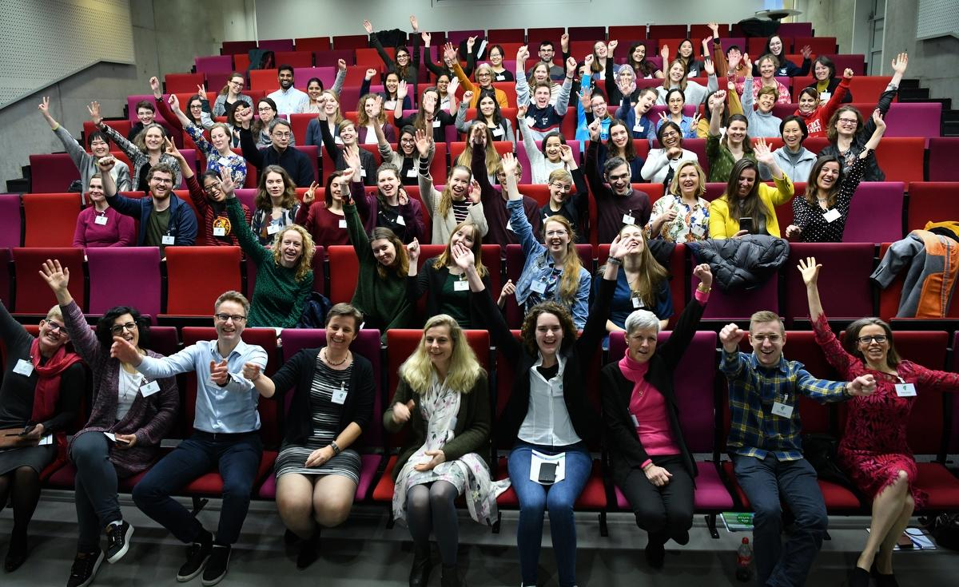
- SUMMARY AND ACKNOWLEDGEMENTS
In the best interest of computer science, diversity among its practitioners is needed. In the light of this given, it is unfortunate that the field is significantly underrepresented by female students, for they, too, contribute to this diversity. Responding to this imbalance is the Alice and Eve-event. Through both an exhibition and a symposium, the event wishes to celebrate the female contributions to computer science. As such, it provides the future generation of female students with role models; providing them with the motivation and aspiration needed to enlist to a similar computer science path. The event has been met with critical acclaim and follow-up plans are currently under development.
Finally, the organization wishes to extend its special thanks to Puck Kemper, who has created the imagery that has become the face of the event. On top of that, the organization wishes to show its appreciation to Jan van der Veen. His continuous support has prompted the writing of this paper. Last but not least, the organization must thank the event’s many sponsors for bringing it into realization. For a complete list, please have a look at [5].

REFERENCES
- W.M.A. Wulf, “The Importance of Diversity in Engineering”, in Diversity in Engineering: Managing the Workforce of the Future. Washington, DC, The National Academies Press, 2002, ch. 3, pp. 8-14.
- J.S. Mill, The Subjection of Women. London, United Kingdom: Longmans, Green, Reader and Dyer, 1869. Accessed on: March 25, 2020. [Online]. Available at: http://www.gutenberg.org/files/27083/27083-h/27083-h.htm.
- N. Darling, “I Could Do That: Why Role Models Matter”, Psychology Today, May 23, 2012. Accessed on March 25, 2020. [Online]. Available at: https://www.psychologytoday.com/us/blog/thinking-about-kids/201205/i-could-do-why-role-models-matter.
- S. Beyer, “Why are women underrepresented in Computer Science? Gender Differences in Stereotypes, Self-Efficacy, Values, and Interests and Predictors of Future CS Course-Taking and Grades”, Computer Science Education, vol. 24, no. 2-3, pp. 153-192, July 03, 2014.
- N. van Huizen & P. Kemper, Alice and Eve: A celebration of women in computing, M. Stoelinga, A. Schaafstal, M. Huisman, S. Lathouwers (Eds.). Enschede, Netherlands: University of Twente, 2020. Accessed on: March 25, 2020. [Online]. Available at: https://research.utwente.nl/en/publications/alice-amp-eve-a-celebration-of-women-in-computing.
- W. Isaacson, The Innovators. London, United Kingdom: Simon & Schuster UK Ltd., 2014.
- M. Huisman, N. van Huizen, P. Kemper, S. Lathouwers, A. Schaafstal & M. Stoelinga, A Celebration of Women in Computer Science: Symposium Booklet. [Brochure]. Enschede, Netherlands: University of Twente, 2020.
- “Alice & Eve 2020”, fmt.ewi.utwente.nl, 2020. [Online]. Accessed on: March 27, 2020. Available at: https://fmt.ewi.utwente.nl/events/aliceandeve2020/.
- “Judith van Stegeren’s comment on the Alice and Eve-Event”, twitter.com, 2020. [Online]. Accessed on: April 1, 2020. Available at: https://twitter.com/jd7h/status/1220721839275683840.

