Appreciations of teaching methods across cultures: Lessons learned from international students
I.C. van Duren & T.A. Groen
Faculty of Geo-Information Science and Earth Observation, University of Twente. Hengelosestraat 99 7514 AE,
Enschede, The Netherlands
Conference Key Areas: (7) Diversity and inclusiveness & (8) Internationalisation, exchange options, joint programs.
Keywords: internationalisation; student centered learning; character traits; higher education

Abstract
Although cultural diversity of students is inspiring, teachers need to consider the variation in educational and cultural backgrounds as well as the different characters of the students. One strategy can be the application of student-centred learning. However, this may affect students that have been accustomed to different teaching strategies. Therefore, the objective of this paper is to assess the appreciation of international students for different teaching methods.
A survey and a workshop were held to ask students for their experiences with different teaching methods before coming to ITC, their appreciation of student-centred learning, and to determine personal character traits.
We found that differences between nationalities were rather small, although there were some suggestions that there are differences in attitude between individuals from different continents. The workshop revealed that teachers should better explain and justify their teaching methods as students do not always understand the reason why certain teaching methods are chosen. Besides, with a mixed group of cultures, teachers must stay aware that students sometimes prefer to give polite rather than honest indications on their learning.

Introduction
The number of foreign students studying in the Netherlands is increasing [1] and internationalisation of education is an important focus area for many higher education institutions. Arguments for institutions to stimulate internationalisation are, that it provides an international context within the classroom, enhancing intercultural awareness, understanding, and acceptance [2]. Although international and cultural diversity of students can be inspiring, it also comes with challenges for teachers. They need to consider the variation in educational and cultural background of the students when designing and implementing education. But often we lack the student’s perceptions on teaching and learning [3]. How this is possibly affected by cultural or educational background is hardly studied before. Most studies to date contrasted groups of “home” versus “international” students (e.g., [4], [5]). A logical starting point therefore is inventorying how teaching methods are perceived by a group of students that is highly mixed in terms of nationalities.
To inventorize the experience and appreciation of teaching methods by students, the educational framework suggested by Chi [6] provides a useful tool. This framework proposes three aspects of teaching which are considered to stimulate deep learning in students: (1) Activity of the student with the goal to activate and actively engage learners as much as possible (2) Construction; creating new outputs based on information provided to students and (3) Interaction with others while learning a topic. These three aspects can be used to group various teaching methods in broader groups.
A typical teaching method that links to the first aspect (Activity) of this framework is student centred learning. This approach is adopted by many universities following a Socratic philosophy to give attention to both cognitive skills as well as meta-cognitive skills (i.e. the learning of the learning) and characteristics of students that may foster or impair the learning progress [7]. A concept that reflects this focus well is student centred learning (SCL; [8]). A workable definition for SCL, and that we will use in this study is (from [8]): “ways of thinking and learning that emphasize student responsibility and activity in learning rather than what the teachers are doing.” This essentially places student responsibility and activity upfront, rather than a strong teacher control or coverage of academic content. However, such control can be hard to handle for students that come from a culture, or an education experience that has not stimulated this responsibility. However, cultural and educational settings are not the only factors that influence the perceptions and abilities of students to handle teaching methods. Also personal character traits can influence this. A convenient way to characterize personal character traits that works across cultures is the framework presented by Ng and Rayner [9]. In this framework, four character traits (Individualists, Fatalists, Hierarchists and Egalitarians) are recognized. People can be a combination of these four traits, but normally one of these four traits dominates.
Therefore, in this study we have inventoried the educational experience and appreciation of different teaching methods of a group of students from a wide variety of countries across the globe. We have asked them to rate different teaching methods using the framework of Chi [6]. Besides we characterized their personal character traits using a situational judgement test (see methods) to find whether either culture or rather character provides the best explanation for possible differences in appreciation of education.

Methodology
Data was collected in a survey in July 2018 in combination with a subsequent workshop in December 2018 among the student population of the faculty ITC of the University of Twente. This involved 32 different nationalities. Study guides and colleagues of the faculty were consulted to list the teaching methods used at the faculty. These were grouped within the framework by Chi [6] (Table 1).
Table 1: Classification of teaching methods within the framework of Chi [6].
Without constructing and interaction | Something is constructed without interaction | Something is constructed with interaction
- Classical classroom lectures  - Reading  - Recorded classroom lectures enabling repeating content  - Unsupervised practical - practice content  - Watching a demonstration  - Self-tests or quizzes  - Searching for extra content additional to material offered by the teacher | - Supervised practical – Individually apply  - Design a conceptual diagram  - Concept mapping  - Learning by doing – individually  - Problem-based learning – Individually  - Physically design something  - Graphically design something | - You, asking questions to a teacher in class  - Classroom lectures with high level of interaction  - One-to-one feedback and discussion with a teacher  - Internet-based question and answer session (e.g. chat, skype or a forum)  - Supervised practical – in a group/acting as a team apply content  - Workshop  - Presenting and explaining content to an audience  - Learning by doing – in a group  - Problem-based learning – in a group  - Project work in a group  - Peer review  - Fieldwork or excursion  - Interview an expert  - Internship

2.1 Survey
The first part of the survey contained general questions on the country of origin, gender etc. Then students were asked to rate all teaching methods using a four-point Likert scale. This forced them to make a choice between “appreciate” or “not appreciate”. The options from which the students had to make a choice were:
(1) I did not appreciate this teaching method
(2) I somewhat appreciated this teaching method
(3) I mostly appreciated this teaching method
(4) I highly appreciated this teaching method
(-) Not applicable, I did not experience this method at ITC.
Lastly, a situational judgement test was added which quantified the four character traits (see [9] for further details).

2.2 Analysis
Based on the opinions of the student population as a whole, a ranking was made from the most to the least appreciated teaching method. Cluster analyses were applied to test if students could be grouped based on appreciation of teaching methods or character traits. The k-means cluster analysis in the cluster package in R ([10]), using silhouette to determine the optimal number of clusters was used. In case specific clusters could be found, it was tested whether these clusters could be linked to certain character traits, or nationalities. Whether a student could be classed in any of the four character categories was done following the method by [9]. Because we had quite many students who were the only one with a particular nationality, we also tested these associations at the level of continents. Chi² tests we used to test for significance of associations between found clusters and nationalities/characters traits.

Results
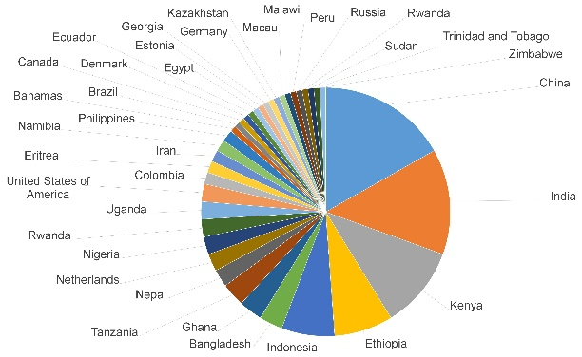
Fig. 1. Origin of students as proportion from the entire student population
After data cleaning and removing survey submissions that were not sufficiently filled in, we ended up with a total of 102 valid recordings. This formed the basis for statistical analyses. Where it was possible to use a larger subset of the recorded data, this is indicated. The cleaned up dataset consisted of 32 nationalities that were present in the faculty, of which five nationalities (China, India, Kenya, Ethiopia and Indonesia) formed the largest groups (figure 1). Almost forty percent of the students was females and just over sixty percent males.
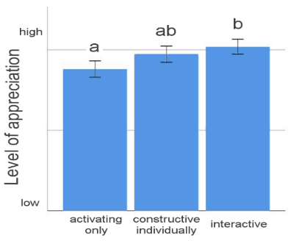
Fig. 2. Relative appreciation of teaching methods within the framework of Chi (2009).
Although student numbers per nationality were too low to draw statistically solid conclusions, we could make some interesting observations about the appreciation of teaching methods and the countries of origin of students. The most striking one is that Ethiopian students scored very consistently the highest appreciation for all teaching methods. In the workshop they hesitantly reacted but confirmed that they always fill in high scores because “they have to be polite”. Some students from Kenya admitted that they also are frequently “polite” because that is how they were brought up. For them the teaching method "peer review” is something they do not feel comfortable with. However, they indicated that with more explanation and by forcing them out of their comfort zone a few times, they had learned over time to do it and their level of appreciation increased. Within the framework of [6], students seem to have a slightly higher preference for the interactive type of teaching methods (figure 2).
Table 2: associations between clustering of the situational judgement test answers and the characters of students and their nationality, aggregated at the level of continents.
 | Cluster |  |  |  |  | Cluster
 | 1 | 2 | 3 |  |  | 1 | 2 | 3
Egalitarian | 8 | 24 | 11 |  | Africa | 10 | 25 | 4
Hierarchist | 7 | 21 | 7 |  | Asia | 25 | 17 | 4
Individualist | 22 | 0 | 2 |  | Europe | 0 | 1 | 0
 |  |  |  |  | North-America | 1 | 0 | 1
 |  |  |  |  | South America | 1 | 2 | 4

Students in the workshop indicated that sometimes they did not understand why they had to work in groups, why the group had a specific group size and why they were judged based on teamwork. Or, more general, they did not understand why a particular teaching method was chosen for a topic.
In the full survey (n=150) we detected very few fatalists (5) and because these were quite a-typical, we excluded these from further analysis. In the cleaned dataset with only valid references, we had 43 egalitarians, 35 hierarchists and 24 individualists.
The cluster analysis revealed that there were no real groups of students that gave very different answers in their appreciation of the different teaching methods. However, clusters could be distinguished based on their answers to the situational judgement test questions to determine their characters. Three clusters could be identified, in which the first cluster mainly linked to individualists, the second cluster linked to both egalitarians and hierarchists, and the third cluster linked mainly to egalitarians (table 2). These associations were significant (Chi² = 42.8, df = 4, p-value < 0.001). We also created spider diagrams of each character trait (See appendix), and this suggested also that hierarchists and egalitarians had fairly similar characteristics.
When organizing the same three clusters along continents from which students originated we find also a slight but significant (Chi² = 19.5, df = 8, p-value = 0.012) association (table 2). It suggests that Asian students have a slight tendency towards cluster 1, and African students towards cluster 2. However, it is also immediately clear that one cannot easily place either origins easily into either clusters, as there is a lot of overlap. For the other continents there are too few observations to draw firm conclusions.
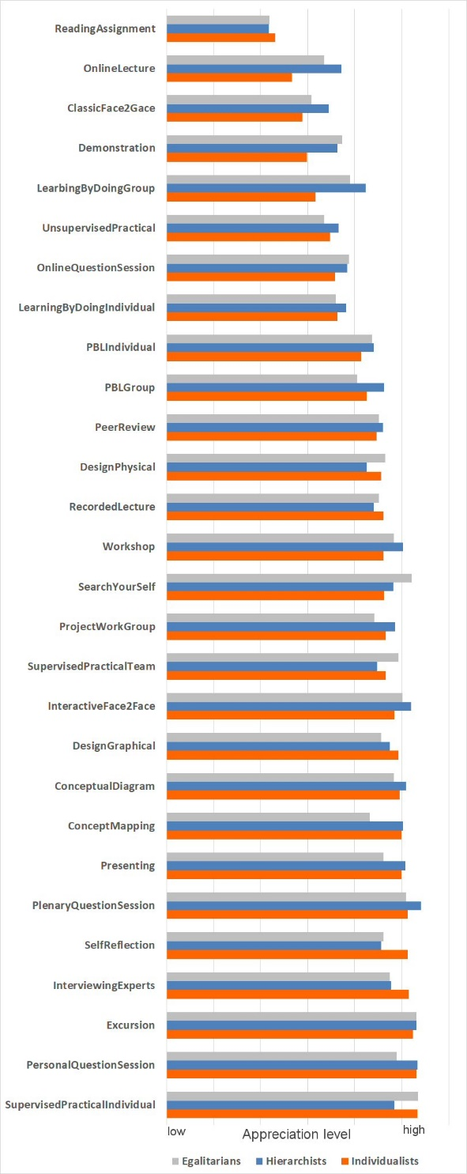
Fig. 3. Appreciation of different teaching methods by students with different characters. N=126.
Based on these results, we tested if there were any differences in appreciation of teaching methods for these three character types which is shown in Figure 3. Generally there are no large differences between the character groups “egalitarians and hierarchists. However, the individualists seem to have a somewhat different opinion on a few teaching/learning methods like a lower appreciation for “learning by doing in groups” and “online lectures”, “classic face to face teaching” and “demonstrations”.
The main outcomes of the survey and the workshop related to internationalization of education and the application of SCL are: (1) The differences between students with different nationalities are often smaller than the differences between individual students with the same nationality. (2) Both, staff and students will benefit if teachers not only explain the content of a topic and how this is going to be taught, but also take it seriously to explain “WHY” it is taught like this. It helps the students understanding their learning process. And perhaps at second thought, with a fresh look at it, teachers discover that sometimes other methods may be more efficient in their teaching.

References
[1] Huberts, D. (2017). Update: Incoming student mobility in Dutch higher education 2016-17. Retrieved from https://www.nuffic.nl/en/publications/find-a-publication/update-incoming-student-mobility-in-dutch-higher-education-2016-17.pdf
[2] Nesdale, D., Todd, P. (1993) Internationalising Australian Universities: The Intercultural Contact Issue. Journal of Tertiary Educational Administration 15: 189‐202.
[3] Fry, H., Ketteridge, S., & Marshall, S. (2009). A handbook for teaching and learning in higher education: enhancing academic practice. London: Routledge.
[4] Saenz, T., Marcoulides, G.A., Junn E., Young R. (1999). The relationship between college experience and academic performance among minority students. The International Journal of Educational Managemen 13: 199‐207.
[5] Srikatanyoo, N., & Gnoth, J. (2005). Quality dimensions in international tertiary education: A Thai prospective students’ perspective. QMJ, 12, 30–40.
[6] Chi, M.T.H. (2009). Active‐Constructive‐Interactive: A Conceptual Framework for Differentiating Learning Activities. Topics in Cognitive Science, 1(1), 73–105. http://doi.org/10.1111/j.1756-8765.2008.01005.x
[7] Vermunt, J.D., Verloop, N. (1999). Congruence and friction between learning and teaching. Learning and Instruction 9 257–280.
[8] Lea, S.J., Stephenson, D., Troy, J. (2003). Higher Education Students' Attitudes to Student-centred Learning: Beyond 'educational bulimia'? Studies in Higher Education 28: 321-334, DOI: 10.1080/03075070309293
[9] Ng R., Rayner S. (2010) Integrating psychometric and cultural theory approaches to formulate an alternative measure of risk perception, Innovation: The European Journal of Social Science Research, 23:2, 85‐100, DOI: 10.1080/13511610.2010.512439
[10] R Core Team (2018). R: A language and environment for statistical computing. R Foundation for Statistical Computing, Vienna, Austria. URL https://www.R-project.org/

Appendix
Spider diagrams on Types of students
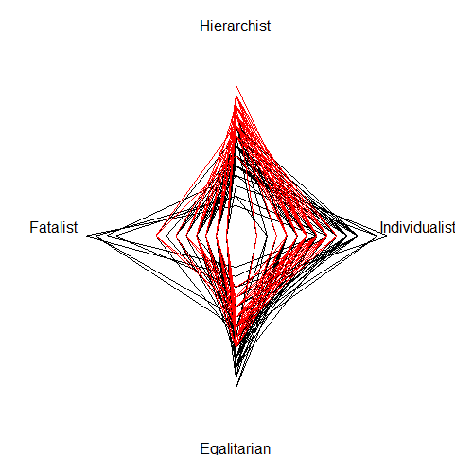  Hierarchists (n=42) | 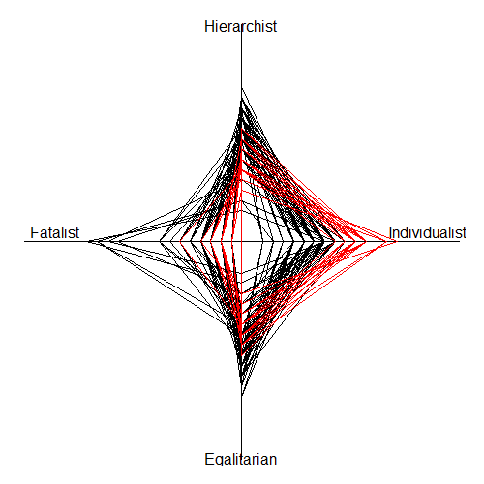  Individualists (n=54)
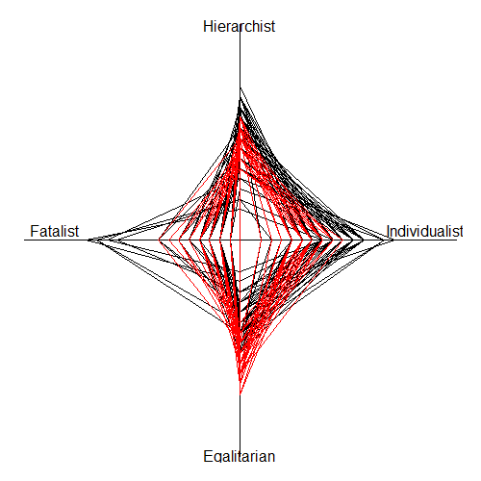  Egalitarians (n=49) | 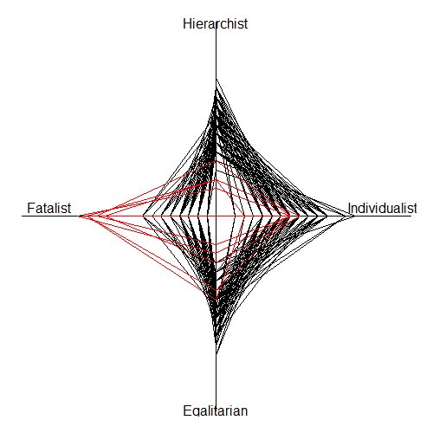  Fatalists (n=5)

Corresponding Author T. A. Groen T.A.Groen@utwente.nl

