Authors:
Dr. George
Exarchakos
Dr. Oded Raz
Dr. Sonia
Gomez
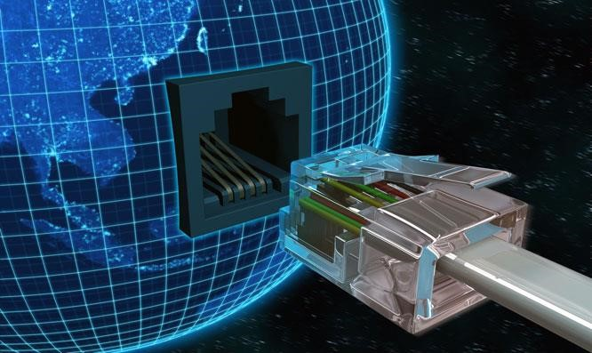

Project title:
Internet Of Things (IOT) innovation space labs

1 Project title and applicants
Project title
Project title: Internet Of Things (IOT) innovation space labs Applicants:
Dr. George Exachrakos, responsible teacher Iot course, EE department Dr. Oded Raz, responsible teacher Iot course, EE department
Dr. Sonia Gomez Puente, Education policy advisor and Project leader, EE department

2 Background and justification of the project
Internet of Things (IoT) is the internetworking of physical devices, vehicles, buildings and other items— embedded with electronics, software, sensors, actuators, and network connectivity enabling these objects to collect and exchange data. As IoT is taking is quickly gaining an industrial foothold in The Netherlands and internationally, engineers with IoT expertise are already needed by many companies. And while a need for this expertise is evident, within the 4TU, and specifically within the TU/e there is no hands-on courses or lab environments where students can be exposed to the IoT experience. The main aim of this project proposal is to create the required IoT innovation space and educate students via practical assignments on all aspects of IoT devices, networks and applications. Therefore, the motivation for this project is to create an IoT innovation space around gravel/net, the expandable wireless IoT network of 50 nodes deployed inside FLUX (See Appendix A for detailed information). The overall goal is to make it possible to run new applications, hosting various sensors and other hardware. This network is the result of several past and ongoing research programs, however it is not yet big and mature enough to be used for educational purposes. It should in principal scale to 180-200 nodes and become robust and easy to use allowing both teachers and students to focus on learning objectives rather than solving technical issues.

3 Objectives and expected outcomes of the project

The objectives of this project are:
- To create an IoT innovative space DBL course within the EE bachelor program to enable students to acquire IoT skills. The DBL course will be an elective course in the 2nd year. The EE-educational management supports the creation of this new DBL course.
- To develop hands-on assignments in which students work in multidisciplinary teams in a DBL lab environment. In this lab environment students prepare a sustainable basis/toolchain and test bed on IoT and related hardware, software and applications.
- To build the infrastructure/facilities for the new IoT DBL course.
- To collaborate with other TU/e departments, namely Computer Science and Industrial Engineering & Innovation Sciences, so that also the multidisciplinary aspects IoT are handled. The teaching staff of Computer Science and Industrial Engineering & Innovation Sciences departments will be also involved in giving form to the content of IoT assignments.
The expected outcomes are:
- A new DBL method is developed for hands-on and innovation and multidisciplinary lab projects.
- IoT skills such as machine-to-machine communications, embedded programming, data processing, web design are taught.
- Infrastructure and facilities for the IoT DBL project are built and a sustainable basis/toolchain for the DBL course is prepared.
- It is expected that students from other TU/e departments, and mainly from Industrial Design and Computer Science will choose this IoT DBL elective course.
Although it is an initiative at this moment, we expect to establish an eco-system around the IoT innovation space lab that will attract companies innovating in the research/application domain. Some linkages with companies supporting this project have been already made (see Letter company in Appendix B). We aim therefore with this project to collaborate with the university by actively contributing to the education of future IoT engineers.
4. Project design, implementation and management:
We provide in table 1 an overview of the project management and phases.

Table 1.
Project management and phases | Project team | Time line
Initial phase
Project organization, coordination meetings & management | Sonia Gomez (project leader) & project content expert team (Oded Raz/Georgios Exarchakos) | Jan., 2017
Project implementation
Construction of the infrastructure/facilities of the gravel/net expandable wireless network | Student assistants | January-May, 2017
Development of Innovation Space | Sonia Gomez (project leader) & project content expert team (Oded Raz/Georgios Exarchakos) | February-April, 2016
Design of the IoT DBL project: lab environment and hands-on assignments | Sonia Gomez (project leader) & project content expert team (Oded Raz/Georgios Exarchakos) | February-April, 2017
IoT DBL Implementation
Training of master/3rd. bachelor students on supervision of students | Sonia Gomez (project leader)/STU trainer project management course
IoT DBL project implementation |  | Sept. through  October, 2017
Evaluation of results |  | November 2017
Students’ questionnaires
Focus groups with students and supervisors
Interviews with teachers
Dissemination |  | From Dec. 2017 onwards
Reduplication of results/linkages with BEP projects
- Project presentation at annual conferences: 4TU CEE, SEFI
- EE education day
- Other TU/e departments
Conference paper |  | Sept., 2017
Final project report |  | December, 2017
Report writing: final report for 3TU management

5 Dissemination and sustainability of the project
The methodology used to design the IoT DBL project will be shared with the teaching staff of the EE department and with the EE OGO-working group who meets regularly. In addition, we strive to developing IoT theme’s based on this innovation space upon which the students can chose to research this topic within the BEP and master projects. This will assure sustainability and reusability of results. In addition, the fact that this project has been submitted together with other TU/e departments supports the dissemination of results, approach and didactical methods. In addition, the EE education day as well as the 4TU education day will be suitable platforms to present results. In addition, international conferences will provide the adequate venue to share the IoT DBL project experience.

7 Signing
Dr. George Exachrakos, responsible teacher Iot course, EE department
______________________
Dr. Oded Raz, responsible teacher Iot course, EE department
______________________
Dr. Sonia Gomez Puente, Education policy advisor and project leader, EE department
_____________________
Ir. Sjoerd Hulshof, Director of Studies, EE department
_____________________
Prof. Johan Lukkien, Computer Science department
_____________________
Prof. Bert Sadowski, Industrial Engineering department

Appendix A. Overview of the infrastructure (gravel/net)

At the moment, gravel/net counts only 50 nodes, some sensors and a middleware for scientific experiments. Each node consists of a) a monitoring platform (i.e. BeagleBone Black) hard-wired to the EE department fixed Ethernet network and power supply, and b) a wireless device to create a wireless IoT network. The middleware allows users to change the operating system, protocols and applications running on the wireless device.
Hardware: To support the IoT DBL course the facility has to scale up to 180-200 nodes as well as to get augmented by energy harvesting low power nodes that will be deployed based on the scenario defined for the IoT challenge and the envisioned application. Additional HW will include WiFi dongles, various sets of sensors (see equipment list below) and several Software Defined Radio modules to support advanced networking and RF techniques which can be included in some applications.
Software: Besides hardware, a network management entity (NME) has to be installed in every node and a server in order to continuously monitor the status of each node, deploy new applications, protocols and operating systems to the IoT wireless device. The NME currently supports a fixed size network, experiment deployment to every node from one user only at any time who is manually authenticated and a limited amount of sensors. For educational purposes, the NME has to manage:
- different concurrent applications hosted on the same or different nodes,
- authentication of individuals and teams of students,
4
IoT: Innovation space labs

Appendices

- scheduling of users and their applications to be deployed on gravel/net at a given moment in future and for a given period,
- mobile nodes that join and leave the gravel/net at any moment.
Deployment and alpha/beta testing: New hardware will be integrated and deployed while software is being matured. The project has four releases, once per quarter.
Moreover, to realize this innovation space, two main activities need to be completed: maturation of gravel/net and design & implementation of the IoT DBL bachelor course.

industry

gravel
/
net

OGO IoT

BEP

BEP

BEP

BEP

Master

Master

Figure 1: TU/e IoT Innovation Space

Appendix B. Letter of company support
4
IoT: Innovation space labs

Appendices

