Intermittent quizzes in video lectures: Making sure they work
Part 2: Evaluation by Students
Daniel Lakens and Chris Snijders

Evaluation of video quizzes by the students.

The second part of this project consists of an evaluation of whether students like the video quizzes. We planned to examine the use of video quizzes experimentally. During this project, it was decided to use the video lectures for a MOOC on Coursera, called “Improving Your Statistical Inferences”. Since there are thousands of students on Coursera, it made more sense to perform the experimental evaluation of video lectures on Coursera. This project is currently being undertaken in collaboration with Tim van der Zee at Leiden University, but results will not be available for some months as we wait for a sufficient number of students to complete the course.

In the course taught at Eindhoven University of Technology, we asked studentss’ expectations about whether they would like video questions before the course started. The question we asked was:

“In this course there will be educational videos. What are your preferences regarding the use of questions in or near videos? Holding the amount of questions constant, I would prefer the questions to be presented as:”
1 As in-video questions interspersed throughout each video
2 As in-video questions at the end of each video
3 As questions after each video
4 As questions after several video
5 None of the above / I prefer to not receive questions

This data indicates that before the course started, students believed they would prefer questions after each video most (31 students), followed by a preference for in-video questions (26 students).
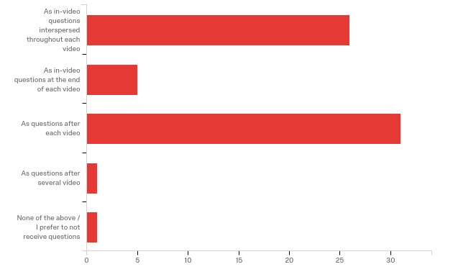

However, after following the lectures, we see students’ preferences shifted massively to a preference for in video questions:
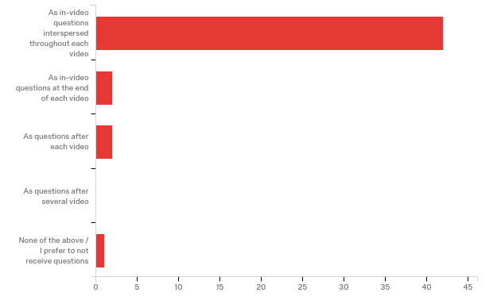
We asked people to explain their preference. Below, we present answers related to the main goal of the project, examining whether in video questions help students to keep their attention to the lecture. As is clear from these responses by students, for many students video quizzes during the lecture helped them to keep attention.

“I think that questions during the video requires me to pay more attention during the entire video, since I can't accurately predict what the question will be about. In the format we received, the questions usually refer to very specific content in the video (e.g. what a certain scientist said about a subject) so I need to pay careful attention in order to get the right answer. As a result, I pay more attention and even take measures to prevent myself getting distracted.”

“To make sure you hold your attention while watching the videos.”

“The questions make me pay more attention and actually trying to understand every concept within the videos. Having all questions spread throught each video allows me to keep focus.”

“they require me to keep my attention up-and-running. I cannot slack off during the videos because I might miss the information that is the answer of the next question. This helps me in learning the material.”

“As in-video questions, it keeps the watcher more active. Reflecting on information during the video gives the feeling you understand the information better.”

“With this option you stay focussed during the video, when you get distracted there is a question and after the question you can focus again on the rest of the video. I think when putting the questions all at the end it is harder to focus and also harder to remember everything that was said in the beginning of the video.”

“Having questions throughout the video makes sure I continue to pay attention.”

“It keeps you focused throughout the whole video”

“Helps memorizing the content which was presented as you try to stay more focussed to answer the questions.”

“Because it makes sure that you keep paying attention, and that's usually hard for me.”

“It keep me focused during all video and give possibilities to check whether I am really listening.”

“It keeps the attention with the video. Also, if you fail to know the answer to a question, you know in which part to look for the answer.”
“I am concentrated throughout the video and actually paying attention, because I know a question is coming soon.”

“The in video questions keep you focussed during the whole lecture”

“Me attention level is higher when I know questions about the provided theory are coming”

“It makes me alert during the video because the question could be on the topic. therefore it has direct consequences if you do not pay attention; you might get the question wrong”

“Furthermore, my opinion towards the in-video questions changed during this course because at first I wasn't very enthousiastic, but later on I realised they really help me stay focused on the videos"

The remaining questions referred to how students liked the questions because it allowed them to test their knowledge of specific sections, because questions could be more easily answered because the topic was just discussed, and because it helped memorize the content of the video lectures.

Conclusion

In this project, we have shown intermittent quizzes can be created in online video lectures using easy to use software (Camtasia), and package in a format that is easily uploaded in a general format (SCORM), as explained in Part 1 of the report. The grades students get for the online quizzes can be stored in the LMS and calculated at the end of the course. Finally, evaluations indicate that even though students initially expected they would prefer quizzes at the end of the lectures, they preferred intermittent video quizzes after experiencing them. Furthermore, students indicated the quizzes helped them to keep their attention with the online video lecture. This project provides support for the idea that intermittent video quizzes are beneficial in online video lectures. Future research (planned in the Coursera course) is needed to examine whether intermittent video quizzes actually improve quiz performance and grades compares to not using intermittent quizzes in online video lectures, but it seems advisable to incorporate intermittent video quizzes in online video lectures.

