Integrating Crowdsourcing in Education:

Investigating its potential for students & teachers
Figure 1: We foresee several benefits both for educators and students in integrating existing tasks from crowdsourcing platforms in existing courses. We foresee that teachers’ workload in that way can decrease while the offer of real-world assignments -to act in a blended education context- can increase.

Dr.ir. Javed Khan
Prof. Dr. Panos Markopoulos
Dr. Migchiel van Diggelen

5 December 2016 – Revised based on feedback
TU/e, Industrial Design Dept.
Submitted for the TU/e Education Innovation Fund 2017

Table of Contents

Applicants: 3
Executive summary 3
Background and justification of the project 4
Crowdsourcing in the classroom 5
Crowdsourcing to activate learning and motivate students 6
Problem-definition 6
Project Objectives 7
Generality of approach 8
Expected outcomes of the project 8
Project design and management 8
Activities 8
Success criteria 10
Potential risks 10
Project budget 10
Signing 11
References 12

Applicants
- Dr.ir. Javed Khan [v.j.khan@tue.nl, http://khan.gr]
- Prof. Dr. Panos Markopoulos [p.markopoulos@tue.nl, http://www.idemployee.id.tue.nl/p.markopoulos/]
- Dr. Migchiel van Diggelen [m.v.diggelen@tue.nl]

Executive summary
Educators actively seek the involvement of external parties in their educational activities to increase the relevance of teaching to society, motivate students and enrich the content of the course with potential applications of the taught material. Whether it is a guest lecture from an industry expert, a project inspired by an industrial context or an internship, all are sought after activities for both students and teachers alike.
Crowdsourcing is a development that has captured the attention of the public. In crowdsourcing, websites -online platforms- offer work, usually in exchange for money, which can be conducted by virtually anyone, but also other tasks that require more specialized skills. Usually, contributors -commonly referred to as “workers”- compete to get the prize associated with the work. There are literally hundreds of different platforms that offer thousands of tasks at the time of writing this proposal. Since tasks are already publicly available online, there is a unique opportunity to integrate their performance in educational activities. Our aspiration is that this integration will: stimulate students’ external motivation; improve students’ understanding of real stakeholders’ requirements and ways of communication; help teachers and students benchmark the students’ competencies in relation to real-world competition; offer teachers a steady and on-demand pool of industry-relevant activities. Our main objective with this project is to integrate crowdsourcing tasks in existing educational activities we offer at the department of Industrial Design to: 1) elicit requirements for its seamless integration; and 2) investigate the effect of crowdsourcing students’ motivation and performance.

Background and justification of the project
Crowdsourcing is an unquestionable development that can potentially revolutionize the way work is done. At the time of writing this proposal, Amazon’s Mechanical Turk –one of the first platforms- has more than 800 thousand work-related tasks (known as HITs: Human Intelligence Tasks) available for completion by workers; Upwork, probably the largest platform for work other than microtasks, claims to have more than eight million workforce from more than 180 countries that have done $750 million worth of work done; 85% of the largest corporates have already used crowdsourcing in the last ten years (Roth, 2015); and one crowdsourcing platform alone has lifted more than forty thousand people out of poverty in developing countries (Q1 2016 Impact Scorecard, 2016).

Crowdsourcing is a novel and emerging trend that promises to transform collaboration and creation, in several domains: creative work (Figure 1), business work, cultural cooperation, etc. As such it represents a field of immense interest for interaction design research but also as a tool that designers can leverage during their creative and production processes. Although there are different definitions of what crowdsourcing is, we prefer to cite the following, encompassing definition: “crowdsourcing is an umbrella term for a variety of approaches that harness the potential of large crowds of people by issuing open calls for contribution to particular tasks” (Geiger et al., 2012). This definition includes paid crowdsourcing but does not restrict other platforms such as social networking systems or other computer supported cooperative systems.

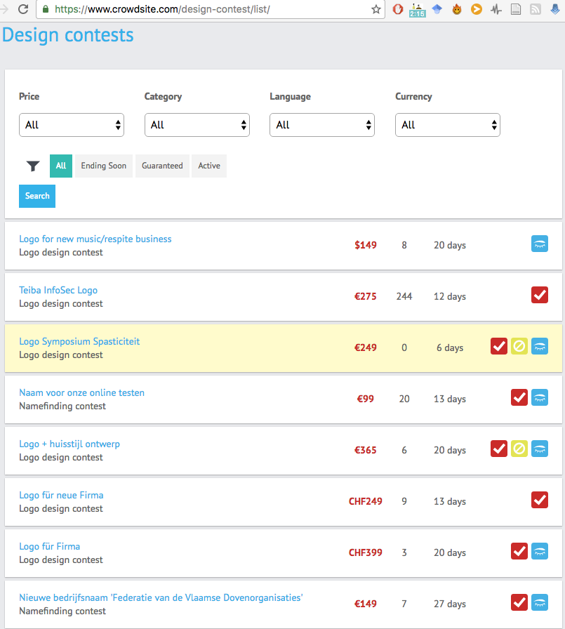
Figure 2: Example of crowdsourcing platform that offers design contests. Those contests can be of typical assignments such as designing a logo but more conceptual ones such as coming up with a new company name or a new product name.

Crowdsourcing in the classroom
Crowdsourcing has potential for education as well (Dow et al., 2013; Xu et al., 2015). Crowdsourcing can be a means to make Higher Education authentic by connecting the content of learning to the real world. Furthermore, it provides the opportunity to tap into the wisdom of the crowd as a potential source of feedback for learning. Using the crowd for feedback is currently affordable and can provide fast results. Crowdsourcing can provide a new perspective on a tough educational issue, namely providing personal, targeted and timely feedback to a diverse and increasing population in Education (Hattie and Timperley, 2007). Next to the potential for providing feedback, crowdsourcing has the potential to bring a plethora of available tasks to education that are diversifying and can be a source of inspiration for teachers. Furthermore, both students and teachers can benchmark their work with the external world.

Another attractive application of such a proposal is that crowdsourcing tasks can potentially be integrated in an e-learning platform. One of the most challenges issues in crowdsourcing is knowing enough about “workers” to be able to effectively assign to them appropriate tasks. We, at the TU/e, already have plethora of information about our students: in Canvas we store material from students’ projects; in websites Industrial Design students assemble their “showcases”; and in the future Canvas promises to also hold rich data about our students and their interactions with lecturers. Such information could prove to be extremely valuable for appropriately assigning crowdsourcing tasks, at the right time, for the right level of our students.

Furthermore, in our face-to-face interactions with students we found out that there is already a limited number of students that are aware and actively engaged in such platforms. Seamlessly connecting those to educational activities might also be an extra, attractive feature of lectures. Finally, completing and succeeding in crowdsourcing tasks can potentially be an extra source of external financial resource for both the university and students alike. Although this is not of direct interest to this study, we would like to highlight it.

In the field of design (research), crowdsourcing is an upcoming technique. Therefore, design students need to learn to use this technique in their processes. Consequently, designers already utilized crowdsourcing in classroom and with promising results. Dow et al. (2013) were one of the first to apply crowdsourcing to a pilot study with three classrooms. The classes were on “human centered innovation” offered by Carnegie Mellon University and Northwestern University –both in the United States. The educators, in addition to traditional activities (such as brainstorming) included “crowd-based” activities such as: gathering comments or blog entries from one or more online forums; gathering on-demand ideas from Amazon’s Mechanical Turk; and evaluated storyboards through the MindSwarms service. According to this study, there are several general and specific educational benefits. An example of general one is that with the help of the crowd students can get formative feedback. A specific one, when it comes to design, is that the crowd can help students “to identify and scope real world opportunities”. Moreover, from the students’ perspective they reported that this approach helped them “identify needs and uncover issues with early-stage prototypes” (Dow et al. 2013). There is more recent evidence that particularly for design related education crowdsourcing feedback can support students to achieve improved designs and is equivalent to expert feedback (Xu et al., 2015).

So, these pilot studies demonstrate the potential of crowdsourcing for enhancing students’ learning. This is not surprising since it can be argued from psychological theories on learning that crowdsourcing has the potential to motivate and activate students. Since 2013, at the User-System Interaction post-masters program of ID, we also deliver a two-week module on utilizing crowdsourcing for design and user research with promising outcomes (Khan et al. 2016). With this project we would like to expand to more educational activities that do not necessarily focus on crowdsourcing but on more general design related topics.

Crowdsourcing to activate learning and motivate students
Crowdsourcing is a tool that has the potential to activate (as opposed to more passive forms of learning) and motivate students. Active learning has been defined differently in the educational literature. According to Shuell (1992) we can speak of active learning when a learner must undertake certain things while processing incoming information in order to learn the material in a meaningful manner. According to recent conceptions of learning that root in constructivism, good learning requires that learners are very active in the sense of determining and controlling their learning (Simons, Van der Linden, and Duffy, 2000). Thus, on the one hand, active learning has to do with making decisions on learning content and on the other hand with making active use of thinking. Learners are supposed to be more motivated and interested when they can make their own decisions about their learning and when their learning is challenged. The extent of student activation can be further enhanced by designing the learning environment (teacher, student, technological tools) deliberately. Examples of aspects that can be taken into account are the extent of authenticity, considering learning as a social activity and contextualizing learning.

In view of the aforementioned points, we believe that crowdsourcing offers many elements that promote active learning and in particular suitable for a blended education context. For example, when it comes to controlling their learning, we expect to offer a plethora of already available tasks. Based on industry reports (Roth 2015, “Reports & Financials” 2016) we expect a steady growth both of tasks within existing platforms as well as new platforms to emerge in the near future. Thus, we would only expect the number and the diversity of the tasks to increase and in that way have an exciting offering of assignments for our students. Another example would be regarding when students’ learning is challenged. Most crowdsourcing tasks are in the form of an open competition. That means that in most of the cases students will be able to see and compare their work with others and in that way offer an environment where challenge is inherent and of global reach.

Problem-definition
Figure 3: The current situation limits both educators and students in the choice that they have for suitable course assignments
Figure 4: We foresee that integrating crowdsourcing tasks in educational activities can provide educators with plenty, steady and diverse set of suitable assignments and also diversify the choice for students. There are several platforms to choose from, the ones we list –Design2Gather, UsabilityHub & Crowdsite is just indicative.
Crowdsourcing has the potential to promote active learning and increase student motivation and its potential has become clear in pilot studies (Dow et al. 2013; Xu et al. 2015).
Yet, crowdsourcing has not been implemented and tested on a large scale. Consequently, the knowledge base on crowdsourcing as a tool in education is just evolving. Up-till-now, little is known about how crowdsourcing can best be integrated in existing education and what its effects are on different types of student outcomes (e.g. motivation) both in terms of learning and in terms of how students perceive its use.

Teacher’s role in ensuring quality for education
Currently there are crowdsourcing platforms (but not specific for supporting education) that offer tasks that teachers could use in their education as assignments. The problem is that the teacher has to: 1) know about these platforms and their diversity 2) make an account and manage a profile in each of these platforms 3) search for tasks on each of them 4) determine whether tasks are suitable for education purposes.

With this project we would like to make this easier for the teacher by developing software that will crawl through these crowdsourcing platforms compiling a list of relevant crowdsourcing tasks, supporting browsing, selecting tasks and assigning them to students.
This software could also be future-proof in that it could be integrated to the Canvas system. We will make sure, before we start implementation, to have talked to the Canvas team to make sure we have build the necessary tools to integrate it to Canvas.

More specifically, the role of the teacher in this project is:
- Provide info about current assignments and workflow. This info is necessary to choose appropriate platforms with tasks that would fit the teacher’s learning objectives.
- Review and search crowdsourcing tasks that could serve as assignments. Our software will list potential crowdsourcing tasks based on keywords that reflect the teacher’s learning objectives.
- Assign tasks to students. Once the teacher has chosen crowdsourcing tasks the teacher will be guided through the process to provide students the necessary info so that they could complete the task. Depending on the crowdsourcing platform it might be that students have to make a copy of their work if the students do not wish to share the platform’s credentials.
- Provide feedback to how we can better integrate crowdsourcing tasks in education. Once teachers have had experience with our software it is necessary to evaluate what would work better to improve their use of the system.

Crowdsourcing is a new phenomenon that will only grow. We can now be the leaders in helping teachers integrate it in their education. This is the first project that tries to do that, to the best of our knowledge.

Project Objectives
This project aims to take a first step in building a knowledge base on how crowdsourcing can best be integrated and how users perceive its effects. Moreover we want to implement crowdsourcing on a larger scale than has been done in the studies (known to us) so far. More particularly, we would like to answer the following research questions:
- What requirements for a crowdsourcing task/platform to be integrated in design education can be defined from relevant literature on crowdsourcing in design and literature on educational theories?
- How do students and teachers perceive a) the use of crowdsourcing and b) its impact on their learning and their motivation?
- What guidelines can be defined for feedback agents (external practitioners), students and teachers involved in using crowdsourcing tasks/platforms?

With this project we have the opportunity to showcase how to successfully integrate crowdsourcing tasks into design education and education at large. Further, the scientific contribution would be to investigate the effects of the proposed integration into student and teacher learning and motivation. Finally, we wish to leave a lasting legacy by designing and implementing a system that will seamlessly integrate crowdsourcing tasks into educational activities that could be used for more courses, other departments and potentially other educational institutions.

Generality of approach
Although this project is focused on design related activities, It can be applicable to educational activities other than design related of interest to TU/e: e.g. computer science (see Upwork.com or Freelancer.com), architecture (see Arcbazar.com/) or even other institutions in the country that teach media (see audiodraft.com), and even general sciences projects (see zooniverse.org).

This proposed integration is also important for raising awareness to a critical mass of students since crowdsourcing is part of what is dubbed as the “fourth generation of computing” (Abowd 2016). Georgia Tech professor Gregory Abowd lists three important developments that to his opinion constitute a fourth wave of computing: Cloud, Crowd and Shroud, as he names them. While the first and last refer to the computing power and devices that are available, the second (Crowd) is a growing trend that can impact not just education but several other crucial aspects of life such as health, artificial intelligence and logistics, just to name a few.

Expected outcomes of the project
More specifically, the expected outcomes of the project are:
- Publish guidelines for embedding crowdsourcing into design education
- Gather data about student motivation in the context of integrating crowdsourcing tasks for their assignments
- Write and academic paper on the project’s results
- Establish closer collaboration with industry for this kind of activities
- Elicit requirements for a platform that would seamlessly integrate crowdsourcing tasks into education
- Design an interactive and working prototype of the platform based on requirements. The main aim of the platform is to help teachers search for and review potential crowdsourcing tasks, from more than one platform, that would fit their educational activities
- Presentation at a (3)TU session

Project design and management

Activities
In addition to the activities we list in Table 1 we would like to highlight that we already have a close collaboration with two Crowdsourcing companies of Dutch origin: Design2Gather.com and Crowdsite.com. These companies are willing to help us with integrating tasks they receive in their own platforms to be served as assignments for our courses. The interest for them is to better understand the needs of young designers in order to improve their platforms. Thus, with this project we have the opportunity to also shape aspects of crowdsourcing platforms to conform to educational activities. The requirements we will draw from a company perspective can inform other companies to adjust their platforms accordingly so that they can be attractive for educational institutions.

Table 1: List of activities to be undertaken and resources involved, with roles of applicants (Javed Khan -JK is the lead applicant, Panos Markopoulos -PM and Migchiel van Diggelen -MvD the co-applicants). Student assistants will help with selected tasks and under the close supervision of the applicants.
 | Description of Activity | Timeline | Resources
 | Make an inventory of all the courses offered in the industrial design department for the 1st semester of the academic year 2017-2018 and the assignments that our students will receive. Also make an inventory of potential courses in either the IE&IS department or the Computer Science Dept. | Jan 2017 | Student assistant
 | Make an inventory of design-relevant crowdsourcing platforms and types of relevant tasks that can be offered in the aforementioned courses | Jan 2017 | Student assistant guided by JK
 | Based on the aforementioned inventories, create concrete potential examples of crowdsourcing tasks that can be offered in class | Feb 2017 | JK, student assistant
 | Try out as a pilot study the integration of crowdsourcing tasks in two courses | Mar-Jun 2017 | JK, PM, student assistant
 | Organize three workshops (one only with teachers, one only with students and one with both) to get their feedback on the general concept and on the specific proposed implementation | Mar 2017 | JK, MvD, student assistant
 | Analyze workshop and pilot data and document requirements for a platform to support this integration | Apr 2017 | JK, MvD, student assistant
 | Design an interactive prototype and evaluate it with teachers and students. Finalize the design of the platform. | May 2017 | JK, PM, student assistant
 | Implement a working prototype of the platform | Jun-Aug 2017 | ICT developer
 | Evaluate the platform in ID courses. Gather data about its use and experience | Sep – Nov 2017 | Student assistant, PM MvD
 | Analyze data and write final report and publication | Dec 2017 | JK, PM, MvD

Although it is our intention to first make an inventory of suitable ID courses and assignments we want to highlight two potential examples that our project could be implemented.

The first example is within the scope of the squads of our department and more specifically the squad: Design for Creatives. The squad hosts roughly 30 students. It is a mixed group comprising of 2nd year students up to master students. Weekly activities include design related workshops such as learning about storyboards that support the early, conceptual phase of design. Moreover, students are expected to integrate all other courses in the confines of a squad. Design2Gather.com has a constant stream of competitions that relate to that early stage of design. A typical competition is coming up with product functionality or a unique concept based on a certain business problem. In this case our squad students could apply the methods they are taught in class to design the conceptual part and product designs of a competition in Design2Gather.com.

The second example is a two-week post-masters course of our User-System Interaction (USI) program. The group ranges between 15 to 20 students. Weekly activities include design related workshops such as learning about ideation techniques. Crowdsite.com has a constant stream of competitions that relate to ideation. A typical competition is coming up with a company or product name with certain constraints (e.g. URL must be available). In this case our USI students could apply the methods they are taught in class to take part in a competition in Crowdsite.com.

A debriefing questionnaire and an exit interview with some of the students will provide us the necessary data to evaluate the effectiveness of crowdsourcing tasks in education.

Success criteria
- Students report higher levels of activation and motivation
- Lecturers report satisfaction in this new way of working particularly for blended education activities
- Other lecturers are interested in integrating crowdsourcing tasks in their lectures
- Students win respective crowdsourcing competitions

Potential risks
A potential risk we can think of is that tasks do not fully align with our educational objectives for scheduling reasons. To mitigate this risk we have already established collaborations with companies in the country. As it was mentioned, Design2Gather is one of them that is interested in helping us with such an endeavor.

Intellectual property (IP) might be an issue since in almost all of the platforms the terms and conditions specify that the IP is transferred to the requester (client of the crowdsourcing task). This is something that might discourage students. However, the courses wherein we plan to integrate crowdsourcing tasks already have an offer of “regular” assignments that students can take instead of the crowdsourcing tasks.

Another potential concern for some may be that crowdsourcing tasks could be potentially designed by a third party to drain ideas from the university perhaps disclosing confidential information. This requires the design of a moderation/vetting structure, to ensure that tasks offered to students are of a type that does not endanger intellectual property of the TU/e. In all cases, using crowdsourcing in this way will be safer than students using crowdsourcing independently, which is possible already outside the university operations.

References
Abowd, G. D. (2016). Beyond weiser: From ubiquitous to collective computing. Computer, 49(1), 17-23.

Dow, S., Gerber, E., & Wong, A. (2013, April). A pilot study of using crowds in the classroom. In Proceedings of the SIGCHI Conference on Human Factors in Computing Systems (pp. 227-236). ACM.

Hattie, J., & Timperley, H. (2007). The power of feedback. Review of educational research, 77(1), 81-112.

Khan, V.J., Dhillon, G., Piso, M., Schelle, K. (2016). Crowdsourcing user and design research. In Collaboration in Creative Design (pp. 121-148). Springer International Publishing, Switzerland.

Reports & Financials. (2016). Retrieved from http://www.samasource.org/impact

Roth, Y., (2015). The state of crowdsourcing in 2015. eYeka.com.

Shuell, T. J. (1992). Designing instructional computing systems for meaningful learning. In Adaptive learning environments (pp. 19-54). Springer Berlin Heidelberg.

Simons, R. J., Van Der Linden, J., & Duffy, T. (Eds.). (2000). New learning. Dordrecht: Kluwer Academic Publishers.

Xu, A., Rao, H., Dow, S. P., & Bailey, B. P. (2015). A classroom study of using crowd feedback in the iterative design process. In Proceedings of the 18th ACM Conference on Computer Supported Cooperative Work & Social Computing (pp. 1637-1648). ACM.

http://mturk.com
http://mindswarms.com

