Guide to using Boundary Crossing Knowledge Clips

Note: You are free to decide the order or which knowledge clips to use. The knowledge clips are made independently without any specific order, the numbering in this document is just to make things a bit clearer to reference, but based on your course needs/context/settings, you are free to decide which knowledge clips to use and which order to use them in. Tip: To get more out of the knowledge clips, you can embed them within an activity or assignment.
An appendix is attached at the end of this document to explain how you can embed these knowledge clips on your course page on Brightspace.
Good luck and we are happy to hear any feedback/comments that you might have about the knowledge clips! If you have any questions, please feel free to contact the BC@WUR core team (Carla Oonk, Karen Fortuin, Nynke Post Uiterweer, Judith Gulikers or Cassandra Tho).

Knowledge Clip 1 – What is a Boundary, a Practice and Boundary Crossing?
This clip explains and gives examples of what a boundary and a practice is, and what boundary crossing is all about.
https://wur.yuja.com/V/Video?v=100044&node=419540&a=870164545&autoplay=1
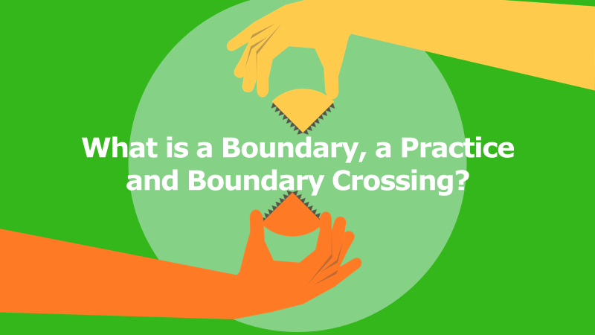
Knowledge Clip 2 – The Importance & Relevance of Boundary Crossing
This clip touches upon the importance and relevance of boundary crossing and introduces boundary crossing competence.
https://wur.yuja.com/V/Video?v=100029&node=419525&a=1302428638&autoplay=1
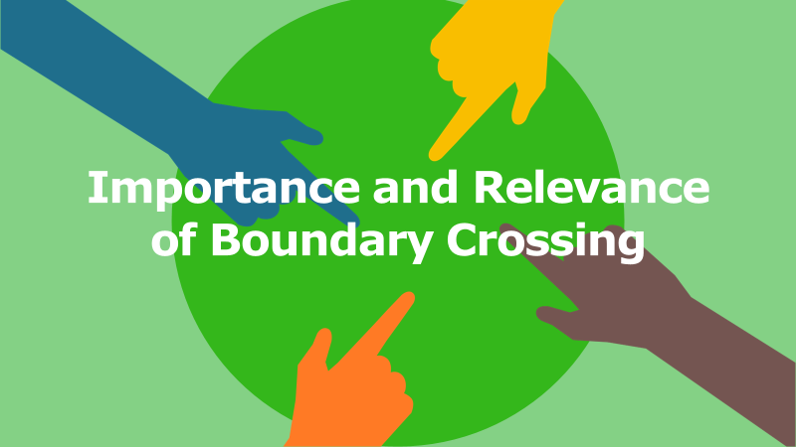

Knowledge Clip 3 – Boundary Crossing Learning Mechanisms
This clip introduces and elucidates the boundary crossing learning mechanisms.
https://wur.yuja.com/V/Video?v=100025&node=419521&a=955682017&autoplay=1
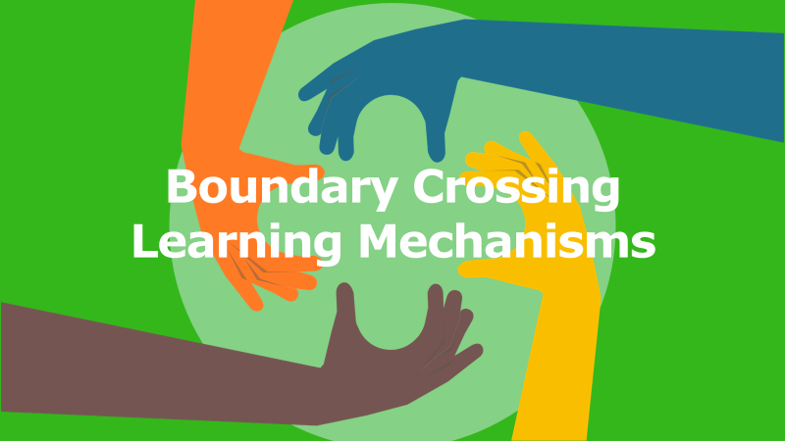
Knowledge Clip 4 – Cultivating your Boundary Crossing Competences
This clip explains and gives examples of what a boundary and a practice is, and what boundary crossing is all about.
https://wur.yuja.com/V/Video?v=100027&node=419523&a=228273546&autoplay=1
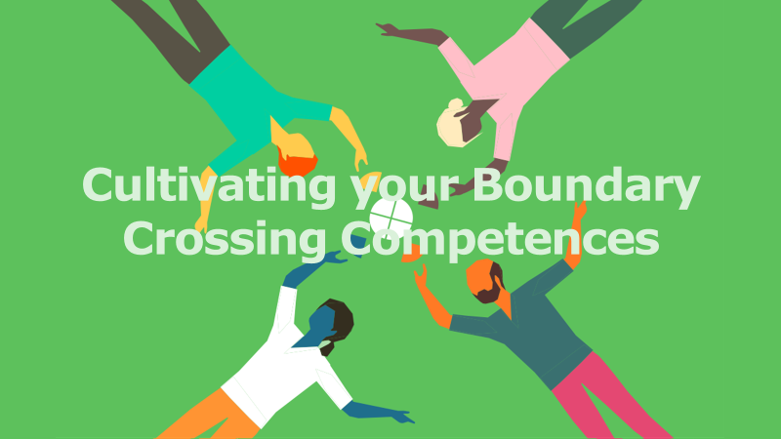

Appendix: Embedding Boundary Crossing Knowledge Clips on your Brightspace course page

Step 1: Decide on which page of your course Brightspace that you would like to include the BC knowledge clips.

Step 2: Click on “Existing Activities” and choose the option of “External Learning Tools”.

Step 3: Click on “Knowledge Clips” (left image). After that there will be an activity titled “Knowledge clips” created on your course Brightspace (right image).

Step 4: Click on “Knowledge clips” and you will be able to see the options available in the wurTV repository. Type “Boundary Crossing” into the search bar and click “search”. The four BC knowledge clips will appear. You can select the clip that you want (we suggest to select the videos one by one, and repeat the steps to put another video).
Once you have selected the knowledge clip that you want, you can pick the display options. We recommend choosing the “Embedded player” option! Once done, remember to click “save”.

Step 5: Once you have saved your option, the chosen knowledge clip will appear as the image below if you chose “Embedded player”. You can then edit the title and change it accordingly to differentiate the knowledge clips for your students to watch! :-)

