**Handout 1: flow chart underpinning**

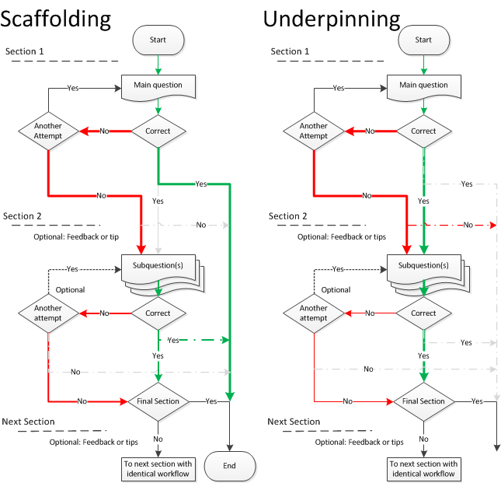

**Handout 2: flow chart scaffolding**



**Handout 3: *create scenario question***

* *Formulate a main questions*

Sometimes there is already a main question in your paper based question.

This can be the last subquestion of the problem.

The main question can also be described in the information part of the problem.

If you don’t already have a main question go back to the level of your learning objective and try to find the desired abstraction level.

* *Formulate subquestions*

If you don’t already have subquestions you could solve the main question in detail and derive subquestions from the answer.

In case of a summative question make sure that the subquestions are not of a lower level than the main question.

In case of a formative question it is a possibility to have subquestions of a lower level in order to help students.



* *Choose a scenario*