Intermittent quizzes in video lectures: Making sure they work
Part 1: Implementing Quizzes in Video Lectures
Daniel Lakens and Chris Snijders

Introduction
Online lectures provide many benefits to students. Students are more flexible in when and where they learn, and they can go through the material at their own pace. However, online lectures also provide challenges. Research examining how students learn has revealed that online education critically depends on self-control skills (Schacter & Szpunar, in press). Self-control fosters the ability to stay on-task when our minds would rather wander. It allows people to restrain momentary desires or distractions to reach long-term goals. One of the biggest challenges students face during lectures is to prevent mind-wandering, and to keep paying attention to the lecture. It is well known that students find it difficult to keep paying attention the longer a lecture takes, and that mind-wandering negatively affects how much students learn from a lecture.
Psychological research has found that one way to prevent mind-wandering during online lectures is to provide short quiz questions throughout an online lecture. Recent studies show that including such short quiz questions improve performance on tests about the lecture content (Soderstrom & Bjork, 2014; Szpunar, Khan, & Schacter, 2013).
In addition to trying to prevent mind-wandering, self-regulated learning requires other meta-cognitive processes. One of these is monitoring how well students understand the contents of the lecture. In classrooms, students can ask clarifying questions (either to fellow students or the lecturer), but this is not possible in online lectures. Intermittent quizzes in video lectures can provide students feedback on how well they understand the lecture content, and have been found to reduce students’ anxiety about the final test for a course (Schacter & Szpunar, in press).
Making online lectures more attractive and easier to set one’s mind to is of special importance in the TU/e context, where the number of courses with substantial numbers of students is large, online lectures are offered more and more, but the attendance to standard online video lectures is low (Gorissen, Van Bruggen, & Jochems, 2012).
These studies provide a clear indication that introducing short quiz questions during video lectures can help to improve students’ performance. However, there are a number of important questions that need to be addressed before these insights can be applied in education. These questions are both theoretical and practical in nature, as we outline below.

Implementing online quizzes in video lectures
We examined the practical aspects of implementing quizzes in online environments. When intermittent quizzes are used in online lectures, one important question is how performance on these quizzes can be tracked. While it is relatively easy to introduce quizzes and questions in online lectures where performance is not tracked (e.g., ‘please pause this video and answer this question for yourself, then continue the video’) actively taking part in quizzes where performance is not tracked is in itself a self-regulation challenge. A further reason to keep track of students’ performance on quizzes during online lectures is that it allows lecturers to easily keep track of topics that require additional clarification during contact hours.
Thus, it is important to examine how we can create quizzes where the performance is tracked, preferably by integrating quizzes in web lectures that are integrated in the Learning Management System(s) used at our university. One of the objectives of this project was to find the best (existing) software to achieve this, and work out the practical details to implement this software in our Learning Management Systems (LMS).
We focused on SCORM compliant solutions (the standard for web-based electronic educational technology) to make sure our solution will work with other (or future) learning management systems. Indeed, this proved important when during the year it became clear the TU/e would be using the CANVAS learning management system. Our choice to focus on a SCORM compliant solution means our current solution does not just work for the system it was testing on (OnCourse, a MOODLE based LMS) but that the exact same material can be imported into CANVAS with the click of a button.
Our practical aim was that any lecturer with a basic understanding of computer software should be able to add quizzes to online videos and analyze the results, as effortlessly as possible.

Software choices
There are a number of software packages that allow teachers to create video quizzes in online lectures, but there are only three real competitors at the moment to easily create SCORM compliant video quizzes: Adobe Captivate, Articulate Storyline, and TechSmith’s Camtasia.
Adobe's Captivate software allows you to create fully functioning interactive lessons with quizzes, scoring, and integration (via SCORM) with Moodle. You can create anything from a simple slide show, to a complete branching software simulation or evaluation, all delivered via Flash without learning any code.
With the complete suite of products from Articulate, it is possible to quickly create e-learning courses from PowerPoint and develop interactive content, quizzes, assessments, and surveys. It is a solution in developing SCORM content for Moodle. Articulate will seamlessly report results to Moodle or CANVAS by uploading the published project as a SCORM package.
Camtasia is a commercial screen-recording product for producing demonstrations and tutorials. It has SCORM compliant output as an option, and permits quizzing and branching. The SCORM output option creates a single .zip file that is appropriate for uploading into a SCORM activity.

Adobe Captivate and Articulate have a huge amount of options which can feel overwhelming for novice users. They are also more expensive compared to Camtasia (which has special prices for education). There are three reasons why we recommend, and decided to use, Camtasia. First, Camtasia is extremely easy to use and has a much lower learning curve than Adobe Captivate and Articulate. Second, Camtasia integrates with Powerpoint, and allows you to easily record your lectures. Although in this project, we decided to record video lectures at the TU/e recording studio, we believe teachers will benefit from the effortless manner in which Camtasia allows you to create a video recording of your own lectures.

The third reason to prefer Camtasia is also most important, and slightly technical. The SCORM format has specific output, which includes the total Score (e.g., for a video lecture with 3 questions, whether learners had 100% correct, 66.67% correct, or 33.33% correct, see below), but not information about each individual question.

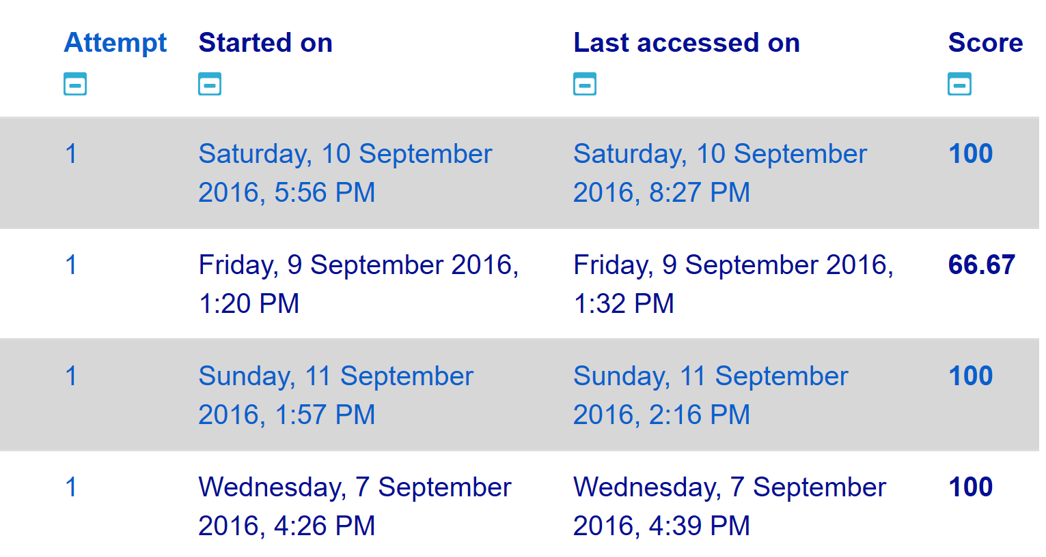

As such, teachers know how well students did overall, and can incorporate these grades in the formal assessment, but teachers can not see which specific questions were difficult for students. TechSmith has acknowledged this limitation in SCORM output, and provides an additional service when creating video lectures, where you can opt-in for free e-mail summaries that contain more detailed information (see the example below). In our view, this option, together with the lower price and ease of use, make Camtasia the best choice of software.

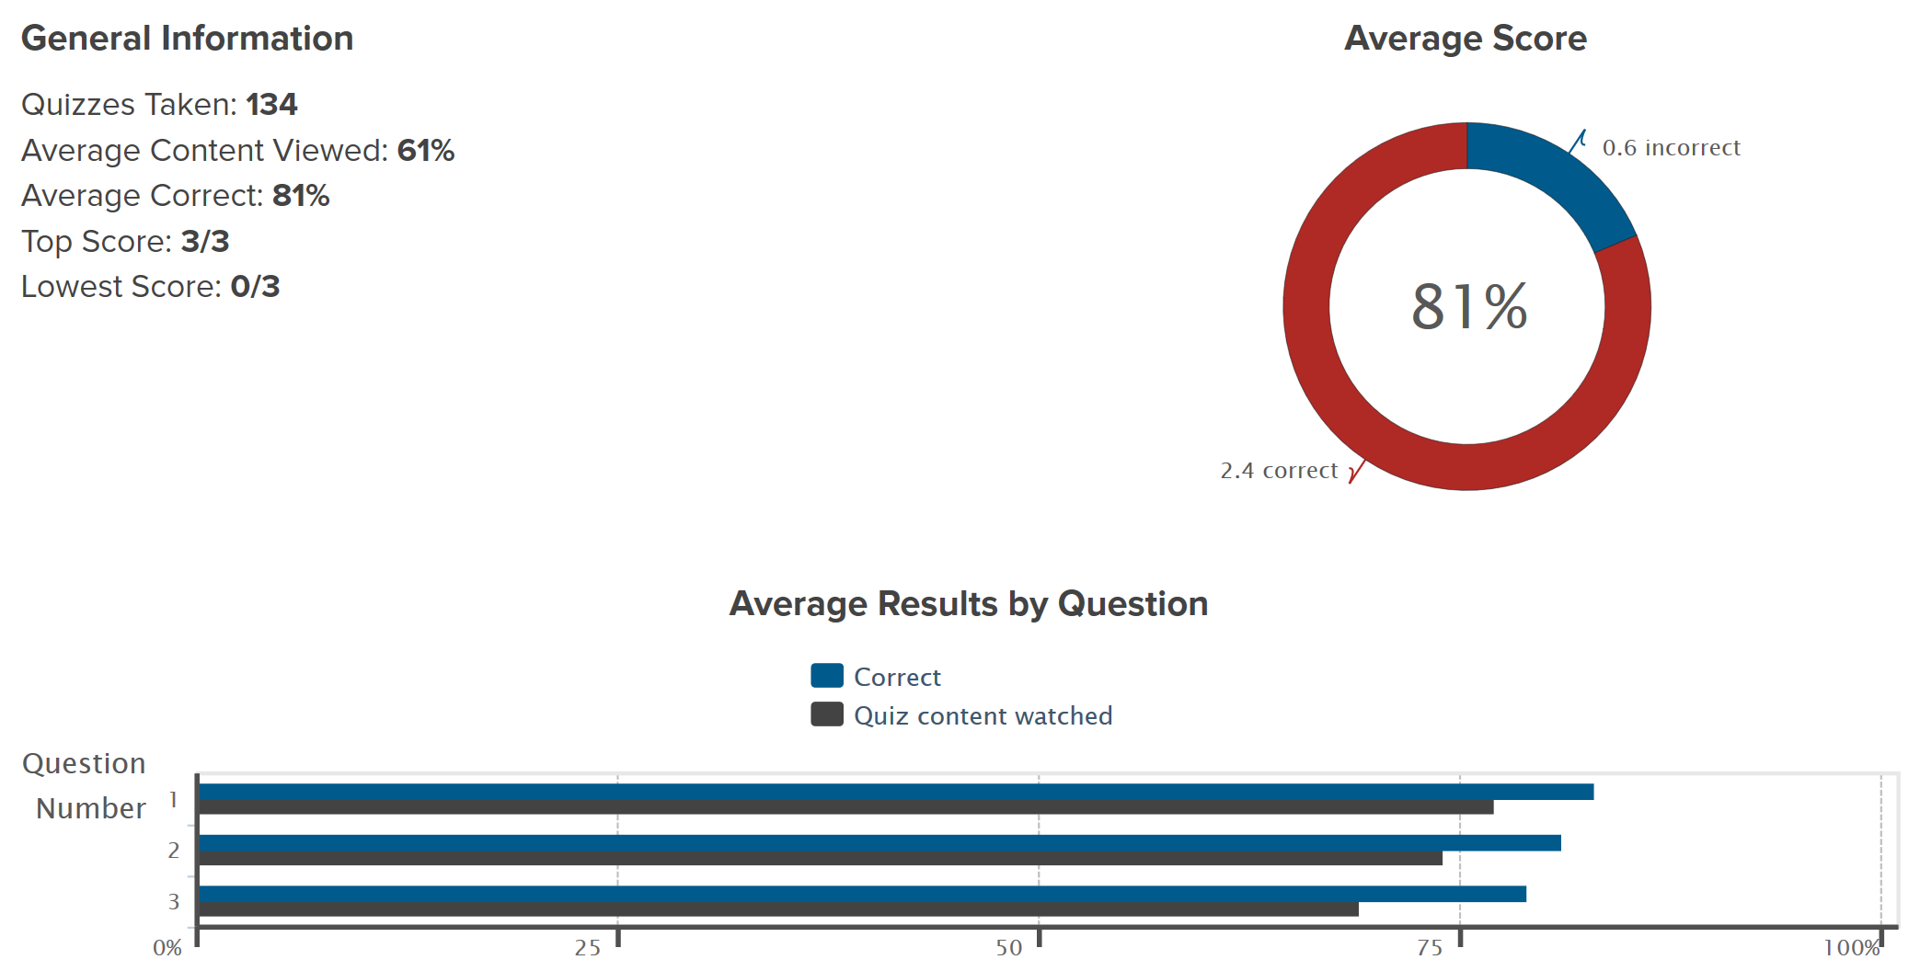
Creating SCORM videos with quizzes in Camtasia and implementing them in the LMS

A benefit of using Camtasia is that the process of adding quizzes to videos, and packaging the videos for SCORM, is straightforward and very well supported through instructional videos. We had planned to create such step-by-step material ourselves, but the Camtasia website is an extremely complete and accessible resource.
A video explaining the process to create video quizzes is provided by Camtasia here:
https://www.techsmith.com/tutorial-camtasia-8-quizzing-1.html
A video explaining the process to create SCORM compliant video quizzes is provided by Camtasia here:
https://assets.techsmith.com/Videos/ua-tutorials-camtasiaStudio-08/2015-scorm-content-packages.mp4
We recommend users to watch these videos, after which it should be very easy to create quizzes in video lectures. In this report,we focus on the specific steps needed to implement these video lectures in an LMS, using OnCourse as an example.

Camtasia allows multiple choice question, true/false question, short answers, and fill in the blank questions. We chose to make multiple choice questions that tested both factual knowledge, applications of knowledge, and simple statistical calculations. A True/False question could be used if simple check of attention are the main goal, while open questions might be suitable to sk students to reflect on information they just learned.

Camtasia allows you to create a .zip file of the SCORM compliant video and quiz:
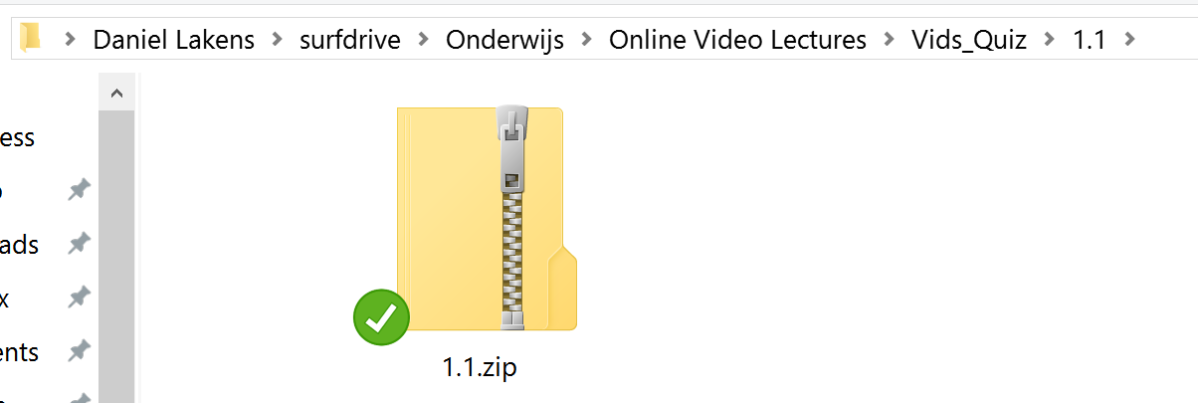
In the LMS, there will be a dedicated input format for SCORM content. In OnCourse, you can click ‘Add activity or Resource’, scroll through the list of options, until you can select ‘SCORM package’:
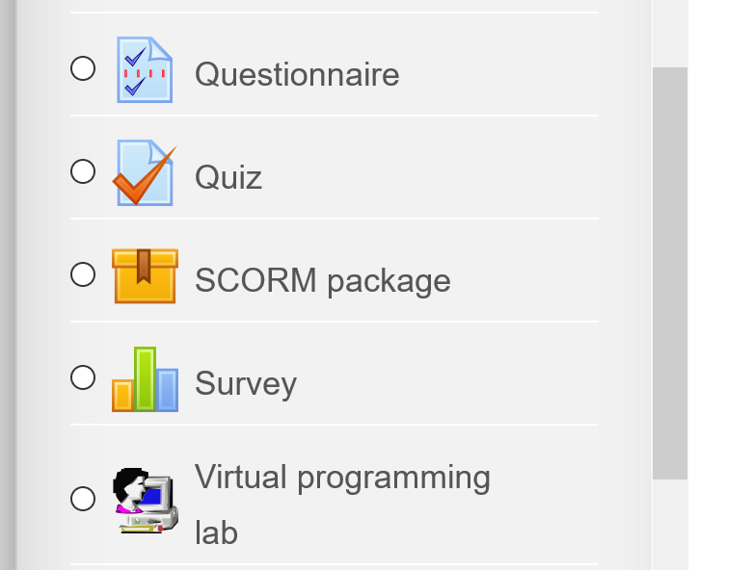
You can just drag and drop the .zip file from your folder to the ‘Files’ section in OnCourse. Keep the maximum file size in mind if your LMS has file size limitations. Even if it does not have limitations, reducing the video size is advisable because your material will be easier to stream over the internet.
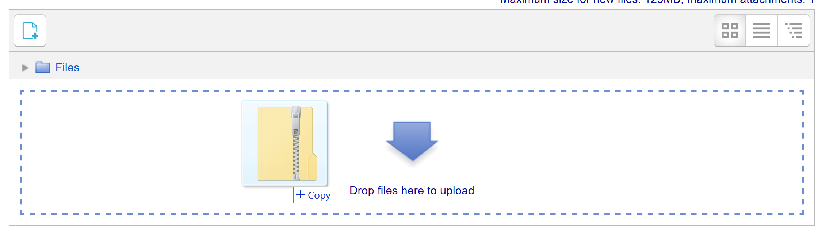
You can adjust the settings for this learning unit similar to any other type of unit on the LMS, including the availability, number of attempts, etc. The video will be playable through the LMS without any problems in our experience. An example of a video with a quiz question in the foreground can be seen below.
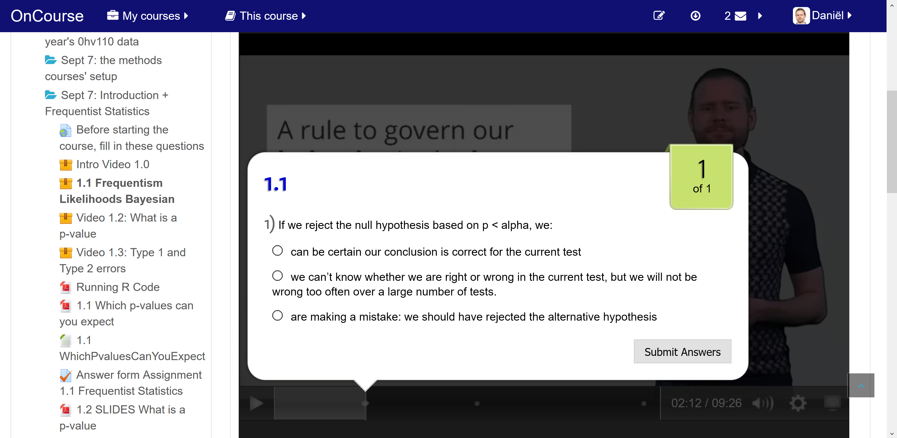

The grades (in terms of percentage of correct answers) will be added to the LMS grader report. An example can be seen below:
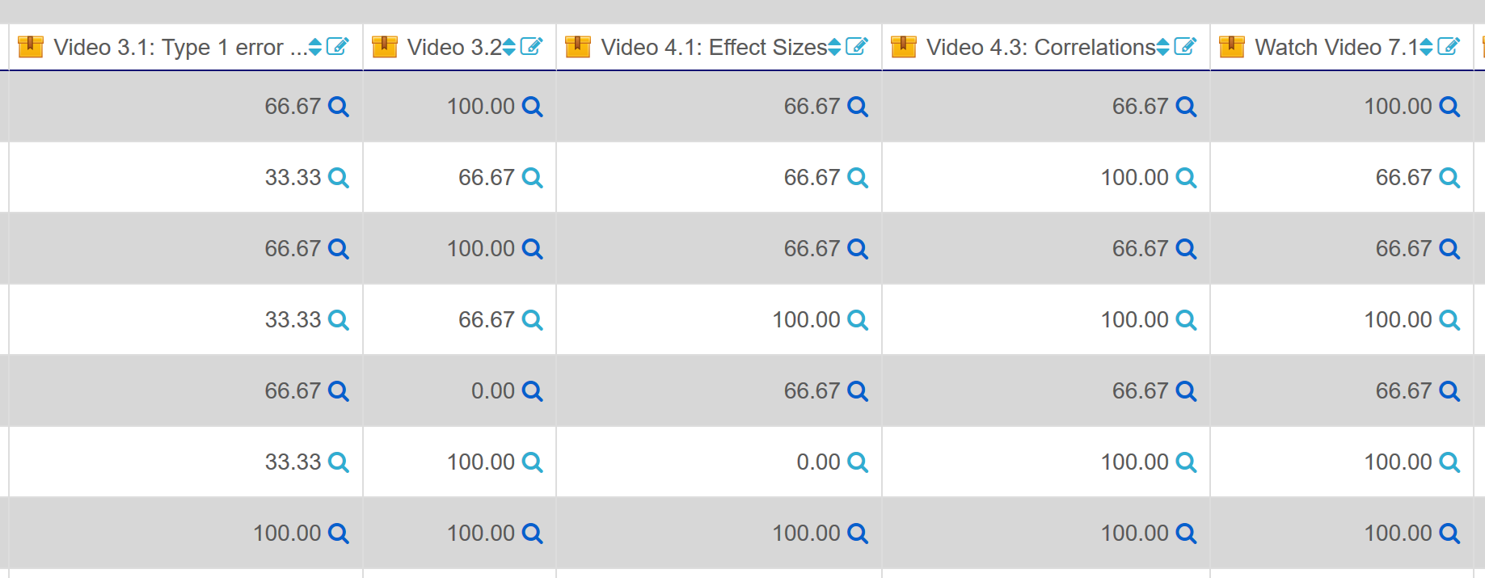
These grades can be combined in the LMS gradebook as normal, and at the end of the course exported.

If required, additional information about specific questions can be found in the more detailed information provided by TechSmith, and example of which is visible below.
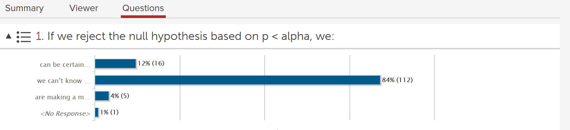
These results can be exported to .csv if required, although in our experience it is sufficient to visually inspect them when preparing for face-to-face contact hours with the students.

In Part 2 of this report, we will discuss the favorable evaluations by students, who in the large majority found these quiz questions a good way to keep their attention.

References
Gorissen, P., Van Bruggen, J. M. & Jochems, W. (2012). Students and recorded lectures: Survey on current use and demands for higher education. Research in Learning Technology, 20, 297-311. DOI: 10.3402/rlt.v20i0.17299
Schacter, D. L., & Szpunar, K. K. (in press). Enhancing attention and memory during video-recorded lectures. Scholarship of Teaching and Learning in Psychology.
Soderstrom, N. C., & Bjork, R. A. (2014). Testing facilitates the regulation of subsequent study time. Journal of Memory and Language, 73, 99-115.
Szpunar, K. K., Khan, N. Y., & Schacter, D. L. (2013). Interpolated memory tests reduce mind wandering and improve learning of online lectures.

