High Tech for a Sustainable Future 2021

Expression of Interest (EoI) Application Form

August 2021

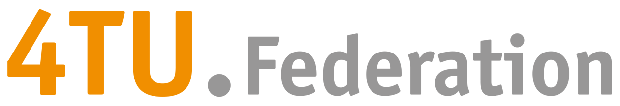
Guidelines:
- Fill out all the requested fields
- Application should be written in English
- Adhere to the word limit +/- 5% (including words in tables and/or captions, excluding references)
- At least two of the four TU’s should be involved in this Expression of Interest
- The complete application form can be a maximum of 3 A4 (including figures and bibliography, excluding the title page)
- You can remove the guidelines (italic) and title page before converting to PDF
- Save your application form as PDF
- Submit the application form to secretaris@4tu.nl
- Deadline: October 6th 2021, 14:00
- Applications submitted after the deadline (October 6th 2021, 14:00) will not be taken into consideration

Contact details (main applicant & envisioned programme leader)
Mandatory
Titles & Name | …………
University | …………
Faculty | …………
Email | ………..
Phone number | ………..

Contact details (co-applicant)
Identify at least one co-applicant from another 4TU University than the main applicant.
Mandatory
Titles & Name | …………
University | …………
Faculty¹ | …………
Email | ………..
Phone number | ………..

Optional
Titles & Name | …………
University | …………
Faculty¹ | …………
Email | ………..
Phone number | ………..

Optional
Titles & Name | …………
University | …………
Faculty¹ | …………
Email | ………..
Phone number | ………..

Proposed programme title
Mandatory
Submit a working title for your envisioned programme

Proposal (max 400 words)
Mandatory
Explain what your topic/idea entails and why it is in line with the HTSF 2021 goals. Include at least the following:
- What is the topic and main research question?
- Why is collaboration between all four 4TU’s indispensable for this topic?
- What is new / high risk about the topic?
- How will the envisioned programme deliver societal impact?
Use max 1 figure.
Word count:

Bibliography

Please check the following box (mandatory)
☐ My proposal does not overlap with the current HTSF programme
If in doubt please elaborate (max 50 words):

Wageningen University and Research: Science Group
https://www.4tu.nl/nl/onderzoek/

