International conference on engineering and product design education
7-8 September 2018, DYSON SCHOOL OF DESIGN ENGINEERING, IMPERIAL COLLEGE, LONDON, UNITED KINGDOM

Deep learning stimulated: 5•5•5•2
Erik W. Thomassen
Faculty of Industrial Design Engineering, TU Delft, Netherlands

Abstract
Teaching manufacturing techniques to 250 bachelor level industrial design engineering students is not straightforward, especially when a fair amount of abstraction is required. Our students find it difficult to grasp abstract matters through a textbook, even when they have lectures delivered by co-authors of the book. We found that students avoided putting their brains to work early-on in the 10-week course, and then faced difficulty nearing the final exam. To overcome this, we encouraged students to come prepared to workshops, where they completed a selection of the textbook exercises under staff guidance. Initially this worked well. Over the years though, as the elaborations of those exercises were shared online, student attendance dropped, despite the available and inviting staff. What more could we do? A solution was found in changing the activities performed by the students. Inspired by Kuttenkeuler and Edström, their concept of ‘time-on-task’ was tried in our education practice. A small part of the grade for theory was earned during the workshops, based on a reward system for delivering a convincing presentation of exercises on the topic at hand. It proved that this method made students come better prepared, in bigger numbers and with a remarkable positive impact on their final exam success rate.

Keywords: didactics, time-on-task, reward system

1 Introduction

To my colleagues in the field…
For all you teaching guys who are struggling to make knowledge stick in other people’s brain, to get student minds to work ‘properly’, to make every hour meaningful: I hope this contribution can inspire you.
The ever more ambitious quality institutions overlooking education in the Netherlands have led to very detailed descriptions of curricula, learning objectives, rubrics. Hence the room to the room to manoeuvre when improving a course is very limited, and changes are mainly incremental. This is a story of one such change. Small, yet effective. But before getting to that, we need some background.

2 The faculty: a brief history
At the Delft University of Technology (TU Delft in short) the department of ‘Technical industrial design’ was founded in 1969 as an ‘in-between-faculty’ between the mother faculty of architecture and the father faculty of mechanical engineering. It was the first of its kind in the world. Its curriculum was originally rooted in its parent faculties, each responsible for the upbringing of certain aspects of their new-born child, later to be called Industrial Design Engineering (IDE). The Delft design history in those early ‘rebel’ years makes interesting reading as a very early example of design education [2]. It took decades for IDE to grow mature and become a faculty in its own right with a fully integrated curriculum. Adulthood came only after a phase in which the relationship with mechanical engineering had first been too close, due to a forced fusion of faculties in 1997 (as if it was forced to live with dad) and after that cooled down. By 2007 this resulted in a new BSc. curriculum which was easier to accomplish in the given time -more doable-, but showed significantly less engineering. Much of the old material science and manufacturing technology was removed, effectively leaving all manufacturing knowledge and practice to be taught in one course, the one which is the discussed in this paper.
At TU Delft we love technology. The faculty of IDE is no exception, but some of our students are. That is to say, not everyone entering the IDE-bachelor course is happily embracing every aspect of technology. Some students have a more artistic image of a designer as a creator of a work of art, ignoring the epithet ‘industrial’, or are suspicious about industry as a whole in the light of the planet’s well-being. Others feel more comfortable in the ‘strategic domain’ and regard materialization issues as less interesting or even inferior problems for others to solve: they do not want to be bothered about the way things are made. In short, we deal with a group of students who do not all share a profound interest in the course content from the start. Of course, we should have corrected their view biases earlier, but this sets the stage for the course now.

3 The course: 'Manufacturing and Design'
In the second quarter of the second year of the bachelor it is finally time to learn about manufacturing aspects in order to take them into consideration in the design process. Arguably rather late, but the good side to that is that the general attitude among students is ‘need-to-know’, according to the course evaluation. Of the respondents, 92% agreed with the phrase “Relevance and contribution of this course for the entire bachelor are clear”.
This course was carefully designed and put into practice in 2007 by my colleague and automotive engineer Erik Tempelman in close cooperation with famous Dutch designer and IDE-professor Bruno Ninaber van Eyben, and has changed little since. Over the course of 10 weeks, with a 20 hours per week workload, a selection of important shape-determining manufacturing techniques is being taught, with a keen eye on the principles behind making things (earlier referred to as ‘abstraction’). The educational material was developed together with specialists from the field of manufacturing resulting in a textbook [3]. At the basis of this new educational design the guiding principles of both contributors were leading. “In design education a long and enduring learning process should take place, relating elements of theory and practice in a way that is meaningful from the students’ perspectives and carefully structured so they can construct meaningful wholes of knowledge, skills and attitudes” (Tempelman et al., 2011 [4]). Ninaber’s vision focuses much more on learning by doing, getting to know a little about a lot in a first read (like ‘scanning the headlines of the newspaper’) and getting to know a lot about a little by studying every detail and communicating with specialists in a highly personal manner.
The design of the course is such that students are inclined to educate themselves further on anything that crosses their future path both as a student and as a design professional. By presenting a selection of seven most important manufacturing techniques for serial production they get to know the basics of those seven. The specialisation project encourages them to go in-depth on one specific technique. This way, they are being trained to go and find manufacturing knowledge in any design situation. In other words: the broadness of the field becomes clear in the seven major techniques (‘shopping windows’) and at the same time the possibility of going beyond that level of understanding is being practiced in the specialisation project. It becomes clear that the education is never finished, and the course shows what to do if additional manufacturing knowledge is needed in the design process, adding to the learning-to-learn principle (figure 1).
Apart from knowledge this has to do with attitude as well. Young students find it hard to present their design ideas to manufacturing companies due to a lack of confidence which in turn is created by a lack of expertise. During this course they learn the value of going out in the field, visit a production plant and communicate about feasibility of their product ideas. This is done in the so-called specialisation project.
Besides the workshops (covering the book and examined in a written test at the end of the course, contributing to 60% of the final grade), and the specialisation project (30% of the course grade) there is 10% left for technical product analysis (TPA). It consists of taking products apart systematically, learning a lot about production of parts and joining and applying theory about assembly.
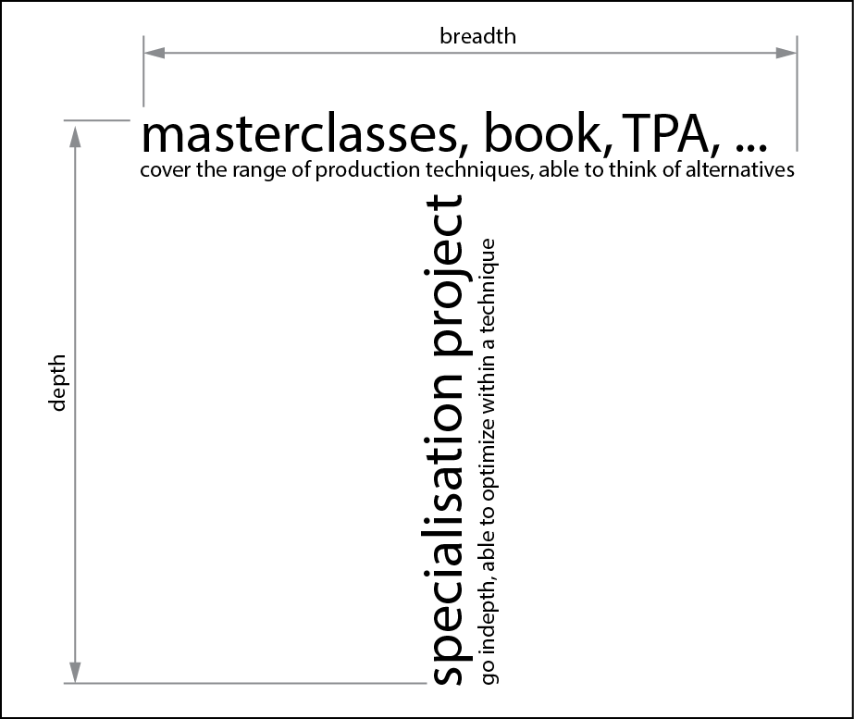
Figure 1. T-shaped course design.

All in all it is a lot to grasp for the students. On top of that, we want to train the abstract thinking, which is why we present the manufacturing on 3 levels being, from abstract to concrete, physical principle (usually caught in a formula), method used, (usually caught in an infographic) to actual machine/tooling (reality, typically caught in a photograph), see figure 2.

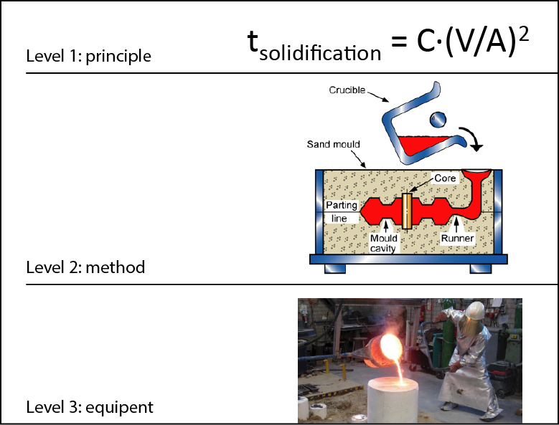
Figure 2. Abstraction levels in studying manufacturing: an example showing casting of metals (adaptation by author from Tempelman et al., 2014).
The reasoning behind the focus on abstraction levels is very legitimate. In the methodology of the design process we are constantly shifting levels. In fact it can be stated that the design process consists of abstraction of a real problem to a theoretical problem, find a theoretical solution for that and make that into a practical one.
Back now to the workshop part of the course, which is the focus of this paper.

4 The problem and its solution
Two years ago we saw a dip in studio attendance during the course and realised the empty studios were a waste of teaching capacity. We needed to encourage students to keep up with the firm pace of the course. The idea was to make the theoretical preparation for the exam during the course count in the exam grade. At that time an inspiring educational conference was hosted between the Dutch Technical universities, at which Swedish educators/engineers Kristina Edström and Jakob Kuttenkeuler explained their way to put ‘time on task’. This meant, make students present their thoughts in a short presentation in class, because, according to their findings, one really learns something when asked to present it to others. Why not combine the two? It was first tried in 2016 and polished in 2017.

4.1 Set up: numbers are important: “5•5•5•2”
With a group of roughly 250 students and the intention to make every student’s learning experience meaningful we need to split up. At IDE we have studios which accommodate 25 students each. We find groups of 5 work well around a table, so five groups of five per studio leaves us needing 10 sessions. Allowing 2 hours for a session enables us to have two successive sessions in one afternoon. So it can be done in five studios simultaneously, with five teacher teams (duos work well, allowing some interaction, redundancy and learning between colleagues). The math explains the title of this contribution: 5•5•5•2. Its product, 250, is the number of students we accommodate in this set-up.

The seven manufacturing techniques are addressed over nine course days, comprising the heart of the course. On such a day, before the morning lecture, a selection of exactly 10 exercises is communicated. After the lecture, students work in groups on these 10 exercises. Naturally, they divide tasks. Ten minutes before the afternoon sessions, the ‘key’ is published. The key links each group to two exercises. All groups go to their studios, each containing 5 student groups. Ten minutes remain to write the solution on the whiteboard. The next hour is used to present the solutions and discuss. The person delivering a convincing solution is rewarded a ‘plus’. Three plusses yield a ‘bonus point’ for the final exam.

Organizing the learning takes a few coordinating actions. First, at the beginning of every week, a selection from the exercises that come with the topics (typically 2 per week) is announced, using the e-Learning environment (we moved from Blackboard to Brightspace, but that is quite comparable).
Second, ten minutes prior to every workshop a division of these exercises is revealed (see figure 3). The systematic numbering of groups makes it easy to allocate, as every studio has 5 groups with letters a through e in their code. The exercises are allocated to late groups differently than to early groups, and the allocation is different every week, to make sure that group preparation is done of all selected exercises, where only 2 are presented per group. The preparation takes a couple of hours, whereas the
10 minutes prior to presentation are just the time needed to present the approach and solution to the

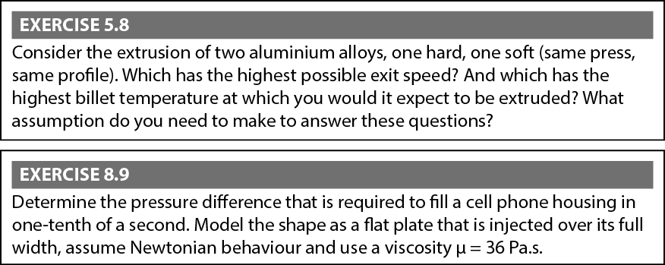
Figure 3. Examples of exercises that made it through the selection from the chapters ‘Extrusion of Metals’ and ‘Injection Molding of Thermoplastics’ respectively (Tempelman et al., 2014).
exercises on the whiteboards that cover the studio walls. The e-Learning environment enables conditional release, so this step is easy to automate.

4.2 Changing the teacher’s role (from expert to time-keeping host, adding a little Socrates)
A special effort was put in the attitude of the teachers in the course. Not only were they asked to be host and timekeeper, making sure all selected exercises could be presented and discussed, but also were they asked to make a switch regarding their expert roll. With a lot of fresh blood coming into the teaching staff it was possible to make a significant step in the role and attitude of the teaching staff as a whole. In my opinion, university teachers at should not try to be clever clogs, but rather evoke the development of understanding and expression of thoughts among students, a lot like Socrates did, according to the dialogues he had with Plato. We want our engineers to be able to reason.

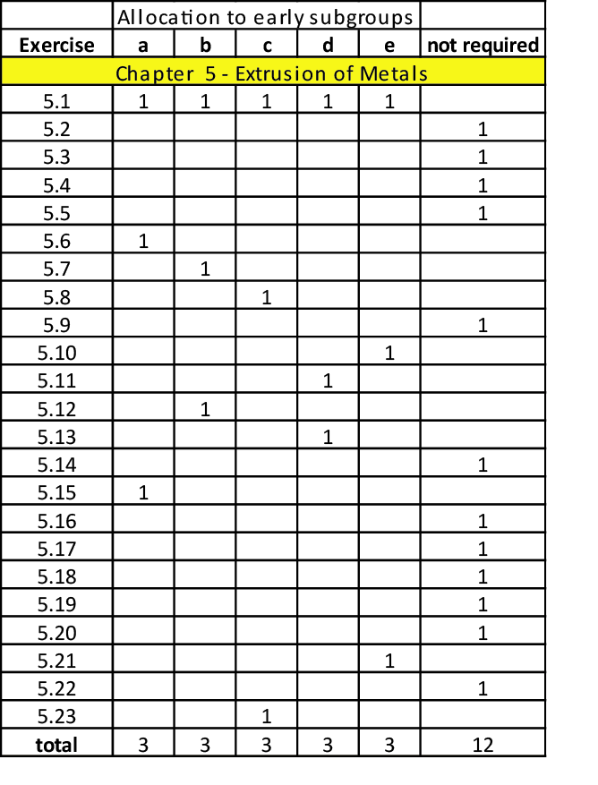
Figure 4. Example of allocation of questions to subgroups.

5 Results

5.1 Student grades
In the latest edition of the course 263 students were enlisted for the final exam, with a pass-rate of 71%. Of the total of students who took the course for the first time only 38 did not have a bonus, mostly because they did not show up enough, sometimes because they did not like the setting.
Those who had received the bonus had seriously participated in the workshops and contributed with at least 3 adequate individual presentations, yielding 3 pluses, which was turned into a ‘bonus’. The bonus meant that exam grade would be raised with a full point on a 10 point scale.
The average final grade of the students with the bonus was 5.91 before bonus, as opposed to 5.30 for those without bonus. So on average they scored a significant 0.61 points higher (figure 5).

5.2 Student and teachers evaluation
In this run, students were very enthusiastic about their teachers according to the afore mentioned questionnaire. Teachers were rather happy, they felt useful and liked too, the atmosphere was great.
More exact results from these evaluations can be produced, but space is running out.

6 Conclusion and Discussion
Adding an incentive to come prepared to the workshops early in the course does not miss its effect on the final result. The promise that every serious student would have a great chance of passing the course motivated the vast majority to be very active throughout. It paid off with a high pass rate and a happy team.
One might question the legitimacy of a bonus system as a means to enhance participation in university level education. Amongst the teaching staff there is a tendency to dislike what we call free cookies earned by just showing up, effective though it may be. In this case, the presentation has to be of a good level to earn the reward, making it more acceptable for staff. And the students? They did not mind at all. In the previously mentioned questionnaire, the phrase “The plus- and bonus point system is a suitable reward system for study behaviour at a university,” was adhered to by a vast majority of 80% (11% neutral, 9% disagreed).

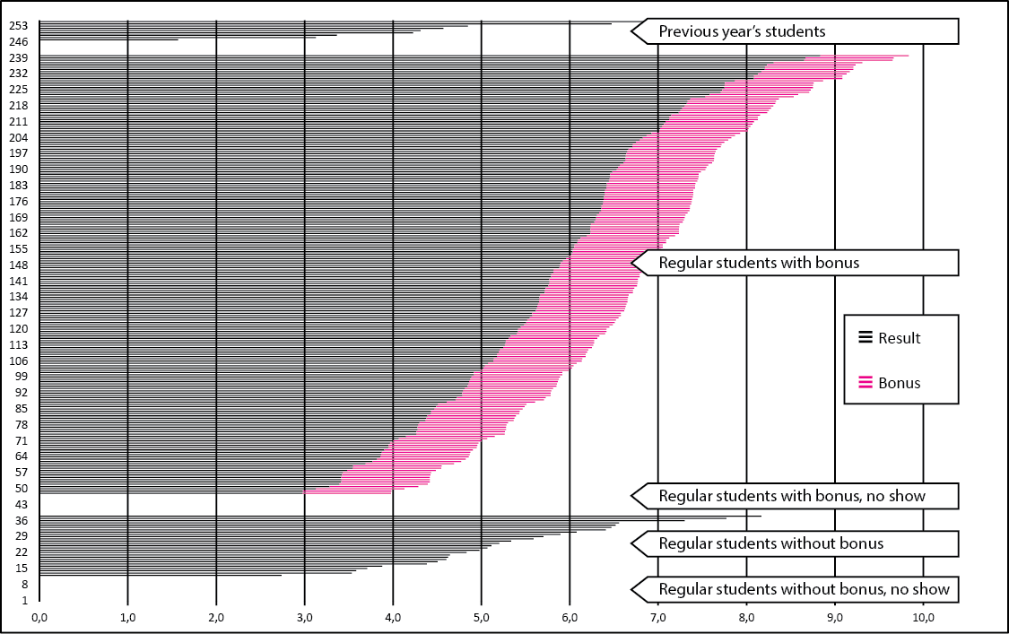

Figure 5. Exam results February 2018 (before resit).

References
[1] Anderson, L. W., & Krathwohl, D. R. (eds.) (2001). A taxonomy for learning, teaching, and assessing: A revision of Bloom's taxonomy of educational objectives. New York: Longman.

[2] Roozenburg, N.F.M., et al. Boerakkerplan, retrieved from: http://www.delftdesignhistory.nl/wp-content/uploads/boerakkerplan.pdf (retrieved 1-3-2018).

[3] Tempelman, E., Shercliff H., and Ninaber van Eyben, B., (2014) Manufacturing and Design, understanding the principles of how things are made. Elsevier, 2014 [1].

[4] Tempelman, E., & Pilot, A. (2010). Strengthening the link between theory and practice in teaching design engineering: an empirical study on a new approach. International Journal of Technology and Design Education, 1-15.

[5] Industrial Production - The Manufacture of Mechanical Products. Kals, H.J.J., Buiting Csikós, Cs., Van Luttervelt, C. A., Moulijn, K. A., Ponsen, J. M., Streppel, A. H. (2016). Boom Uitgevers Amsterdam (Fifth Edition).

[6] Roozenburg, N.F.M., & Eekels, J. (2005). Product design: Fundamentals and methods. Chichester, UK: Wiley.

[7] Plato, The Dialogues of Plato translated into English with Analyses and Introductions. B. Jowett, M.A. in Five Volumes. 3rd edition revised and corrected (Oxford University Press, 1892). Visited 3/5/2018.

Kristina Edström is an Associate Professor in Engineering Education Development, Dr. Jakob Kuttenkeuler is a Professor in Naval Architecture, both at KTH Royal Institute of Technology, Sweden. Contribution to 4TU Engineering Education Conference (Delft, 2016).
Pouw, Student evaluation 2040-17_Manufacturing and Design_Results_1718 (pdf, internal).
A very clear methodology which was developed at our faculty can be found in Roozenburg & Eekels, (2005) [6].
4TU Engineering Education Conference (Delft, 2016).
IDE-Studios are equipped with 5 large, height-adjustable tables on wheels, ergonomic chairs, whiteboards covering many metres of side walls and a large screen display.
This theoretical part takes place in the first 6 weeks only. At the same time, the coaches are engaged in supervising the other projects as well. After 6 weeks, all attention goes to the projects.
In the example (figure 4) three exercises per group are given. Although the first exercise of every chapter is very important (‘Bing a product from home that was made with the manufacturing technique at hand’), this question is too easy to yield a ‘plus’.
Meno is an example of such a dialogue. By asking questions, Socrates appears the person to be educated by the dialogue. The questions are clever and his opponent is gaining insight when forced to clarify his thoughts. Examples can be found in The Dialogues [7].

