THE SENIOR UNIVERSITY TEACHING QUALIFICATION: ENGAGING IN RESEARCH, DESIGN AND BUILDING COMMUNITY IN ENGINEERING EDUCATION

C. L. Poortman
Assistant Professor ELAN Dept. of Teacher Development
University of Twente, Enschede, the Netherlands
E-mail: c.l.poortman@utwente.nl

C. Rouwenhorst
Educational consultant
Centre of Expertise in Learning and Teaching (CELT)
University of Twente, Enschede, the Netherlands
E-mail: chris.rouwenhorst@utwente.nl

M. ten Voorde – Ter Braack
Educational consultant
Centre of Expertise in Learning and Teaching (CELT)
University of Twente, Enschede, the Netherlands
E-mail: m.terbraack@utwente.nl

J.T. van der Veen
Associate Professor
Chair 4TU Centre for Engineering Education, ELAN Dept. of Teacher Development
University of Twente, Enschede, the Netherlands
E-mail: j.t.vanderveen@utwente.nl

Abstract
For a high standard of educational quality and success rates, teaching quality is key. Teachers need to be supported in their professional development aimed at achieving the ambitious goals of student-driven engineering education. Moreover, educational excellence is often confined to ‘pockets’: good practices are confined to one program or department and not shared beyond. Creating opportunities for teachers to collaboratively reflect on, further develop and share knowledge and practice-based research to promote educational innovation is very important. The Senior University Teaching Qualification (SUTQ) is focused on a scholarly approach of teaching and learning (SoTL; Graham, 2018), in which teachers are regarded as researcher and designer of their own educational practice, to collaboratively innovate and improve teaching.

SUTQ participants determine their personal learning path and execute their own sub-project (160 hours) to innovate and improve their practice. They are supported by a coach, educational research and design seminars, and peer-feedback from colleagues. After three years of running and adjusting this approach based on the literature, evaluations, experiences and outcomes, this paper shows both the benefits and the challenges of organizing this type of professional development. Although participants feel inspired, appreciate the clarity, usefulness and feedback during SUTQ sessions, some challenges remain both in terms of facilitation (e.g., time) and the approach (e.g., the steps from clear problem statement to innovation design). Additionally, community-building needs more attention, to promote further continuous development in the university as a whole. In this concept paper we set out an agenda for doing so.

INTRODUCTION

The senior university teaching qualification
Teaching quality is key for a high standard of educational quality and success rates. To achieve the ambitious goals of student-driven engineering education, teachers need to be supported in their professional development. Moreover, educational excellence is often confined to ‘pockets’: good practices are confined to one program or department and not shared beyond. Creating opportunities for teachers to collaboratively reflect on, further develop and share knowledge and practice-based research to promote educational innovation is important. The Senior University Teaching Qualification (SUTQ) is focused on a scholarly approach of teaching and learning (SoTL) [1], in which teachers are regarded as researcher and designer of their own educational practice, to collaboratively innovate and improve teaching.

SUTQ participants determine their personal learning path and execute their own sub-project (160 hours) to innovate and improve their practice. They are supported by a coach, educational research and design seminars, and peer-feedback from colleagues. After running this program twice and adjustments based on the literature, evaluations, experiences and outcomes, this paper shows both the benefits and the challenges of organizing this type of professional development, and what needs further attention to make it even more succesful both for individual teachers and the university as a whole.

Framework and design

1.2.1 SUTQ vision and goals

At this University the career framework for university teaching [1] is used, referring to four levels (see Figure 1). Based on this career framework for teaching, teachers develop their competencies via SUTQ at the level of the ‘skilled and collegial teacher’ (2nd level), ready to contribute to the pedagogical knowledge in their own field of teaching (3rd level, of the ‘scholarly teacher’). The target group for participation in SUTQ are (experienced) teachers that have both obtained their basic University Teaching Qualification (UTQ), and are considered forerunners in their department in terms of teaching.

Participants are expected to
- be committed to and focused on improving education focused on student learning
- be critical and proactive concerning education and their own role
- be informed of and have an open mind for state of the art developments in the field of education
- give direction to and are in control of their professionalization
- be committed to the activities and collaborate with fellow participants during the SUTQ trajectory

1.2.2 Approach

The SUTQ trajectory consists of an intake, a two-hour kick-off meeting to explain the program and to get to know all participants, and several ‘research and development’ seminars about educational (design) research over a period of a year (may-april). Support is available in the form of (group) coaches intervision sessions, group (lunch and/or writing) meetings and individual feedback from the coaches. The seminars are scheduled from late afternoon, to and including the evening (around 8 pm, including dinner). For each participant resources for work visits, participation in (international) workshops or conferences are also available. A digital learning environment was set up to inform participants and coordinate the program. Characteristics such as a longer-term program (a trajectory of activities rather than one-shot workshops), structured and guided activities related to practice and a (collective) focus on student learning, as applied in this program, are important conditions for effective professional development [2].

In the first pilot program, 17 teachers participated, ranging from teachers/researchers to professors from a variety of faculties and educational programmes. The intake consisted of a meeting between the SUTQ coordinators, the participant and their director of education. Directors of education were involved to explain SUTQ to them – given that this was new at the University. Because of their role of final assessor (one of the assessors), it was important to clarify this role and responsibility. Additionally, we aimed for directors’ support of the teachers’ participation in SUTQ. Participants are doing research in their practice that is usually also relevant for colleague teachers in the department. Directors’ support is needed to help participants disseminate knowledge, for example in dept. meetings.

Apart from facilitation of the participants’ active participation by the department, their topics of interest were also discussed. In a kick-off meeting with all participants, they pitched their project ideas and got to know each other and the coaches and seminar lecturers. The seminars (2 initially), were focused on explaining the process of educational (design) research focused on improving teaching. Inspiration sessions, for example about ‘flipping the classroom’, were also organized. Sessions with the coaches, organized in groups of 4-5 participants, were aimed at motivation and more in-depth peer feedback on products from the participating teachers. The kick off session, seminars, inspiration sessions and coach sessions were also aimed at building the SUTQ community.
At the end of the SUTQ track the participant is expected to deliver the following three products: (1) their own SUTQ product fitting with the educational question (article, design, advice, etc.), (2) poster of SUTQ results (See Figure 2) and (3) a reflection report. This is reviewed by a committee consisting of the participant’s program director, a self-selected peer, and an educational expert. Apart from a review of the written products, a review meeting takes place as the final meeting.

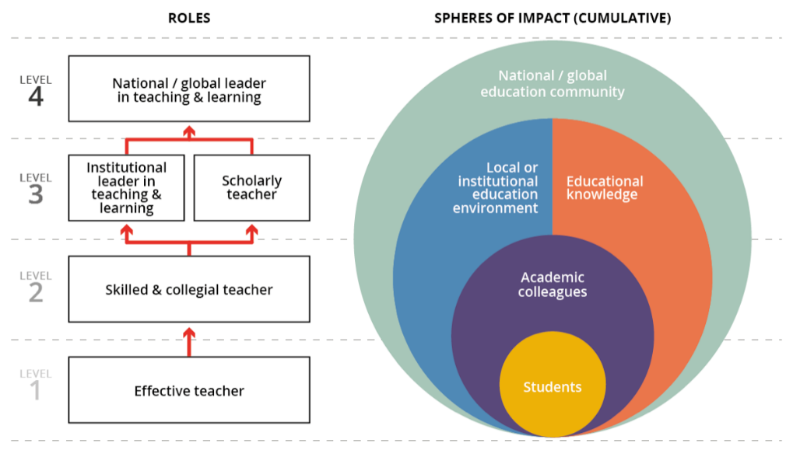

Fig.1 Career framework for university teaching [1].

Outcomes, evaluation and adaptation

Pilot program

The outcomes [3] in the pilot year showed that teachers worked on a large variety of themes, such as ‘flipping the classroom’, ‘why do students plagiarize’, ‘serious games’, and a ‘hybrid test for mathematics’. Assumptions about their themes, such as flipping the classroom (are not automatically effective), motivation in serious gaming (is not automatically promoted), and student-centered learning (students with a hierarchical background do not have a less favorable opinion about SCL than other students) were often rejected. Participants learned more about their theme (e.g. ‘wicked problems’ in education); how to do (qualitative) research to innovate their teaching and how to adapt teaching based on data collection about their theme with students, such as amount of feedback and clarity of assignments.

Challenges were, for example, to actively involve colleagues, to conduct social science research with an engineering background, and integrating research design and course design (being able to experiment with an innovative course design and researching it at the same time). Participants were proud of achieving the planned outcome (for example, a ‘hybrid’ test - partially open and partially closed, with reliability and validity comparable to paper and pencil tests; or taking on the challenge to critically reflect on teaching with help of student feedback).

The first evaluation of this pilot program showed three main elements of improvement: priority and facilitation in participants’ departments (and, in relation, feasibility); opportunities to interact more with peers; complexity of the R&D seminars, where the focus was on research at the cost of designing for innovating teaching [3] and there was too little time to cover all relevant aspects sufficiently.

Second cohort

In the second run of the program, 15 teachers participated. The intake procedure was adapted in line with the pilot program evaluation results. Potential participants needed to fill out an application, including their motivation, and also needed to make a start with their research proposal already, to show both commitment and feasibility of their intended project (in their department).

We made two further major changes based on experiences and evaluation outcomes of the pilot (e.g., colleague involvement/priority at dept., conducting social science research and seminar complexity, integrating course and research design – i.e. also feasibility of the project; and interacting with peers).
Firstly, we extended the kick-off session from two hours to one-and-a-half days, in which participants did not only have the opportunity to get to know each other and the coaches and lecturers better, but also to work further on their research proposal, with help of the coaches and lecturers. Involving directors of education in the former intake procedure was replaced by inviting them to part of the kick-off session.
We also decided to implement a ‘go/no go’ procedure, to encourage participants to think through their research early enough to enhance feasibility of their project. Participants needed to submit their research proposal six weeks after the kick-off session to be reviewed by one of the coaches and one of the seminar lecturers, to ensure all participants would have a complete and well-structured proposal before data collection. Before the end of this six-week period the first seminar had already taken place (three weeks after the kick-off session), to make sure participants had received more input and feedback before the go-no go moment. In terms of peer interaction, we implemented explicit peer feedback and discussion moments within the kick-off session, seminars and in the meetings with the group coaches.

Regarding the seminars, we decided to cover part of the seminar content in the (extended) kick-off meeting already, to support participants in developing their problem statement, research questions and theoretical framework early on. The next two seminars were planned a month and four months later to go into design and data analysis, and evaluation and communication of the project. Writing sessions were added for participants to be able to receive more just-in-time feedback of the coaches and seminar lecturers in a later stage.

The outcomes [4] of the second cohort again show a variety of themes, such as enhancing intercultural sensitivity, flipped micro lectures, and entrepreneurship, but also several student-driven learning sub themes, such as tailoring personal student paths.
Several participants noted how they became more aware of explicit teaching assumptions and strategies as an outcome of SUTQ, e.g., from “I did many things on my gut feeling” and “previously, I always used my intuition in ideas about educational improvements” to “I have learnt a lot about the fundamental nature of learning processes (…) the educational literature (…) to integrate classic engineering topics …with ideas about teaching”. Participants also mentioned student diversity (in background, prior knowledge, expectations) and positive student engagement as something they became much more aware of.
Although finding time to spend on SUTQ was still noted as a challenge by several participants, interestingly most participants mentioned the value and appreciation of being able to discuss and further develop their teaching with input both from students and colleagues (at their department) within the SUTQ framework, e.g.: “many colleagues and students were interested in my SUTQ topic and liked to contribute to it”. Several participants also mentioned being proud of becoming part of a community presenting and discussing research into education more confidently. Several have (started to) publish(ed) their SUTQ report as a paper in peer-reviewed journals, and/or have submitted or already presented at (engineering) education conferences.

Constraining the boundaries of their study, again in relation to finding time, was a challenge for some participants again, although some mentioned that the clear structure and timelines of the program helped in this respect. Run time was confining for some participants, not allowing the opportunity to collect data in each possible teaching quartile. For some participants particular social science research activities were mentioned as the biggest challenge they experienced, e.g. doing a focus group and “I have never coded and analyzed transcripts before”.
Apart from intermediate evaluations focusing on strong points and aspects for improvement by the program coordinators, the program was also evaluated by a Master student [5]. The goal was to formatively evaluate SUTQ, to identify further potential areas for improvement, focused on alignment of the SUTQ program with the institutional context and participants’ needs. This study employed multiple qualitative research methods including document analysis, interviews and a focus group session. Main outcomes of the evaluation where focused on the research approach, differences in prior knowledge, feasibility, and community building. Regarding the research approach, some of the participants had not expected a focus on educational research and had expected the content to be more about pedagogical strategies and/or accreditation issues. Prior knowledge of the participants (and their perception thereof) in terms of social science research background was very different.

Regarding feasibility, the start- and end date and run time of the program did not offer the opportunity to study and implement in each possible quartile, although the idea is that participants are allowed to select the module that is the subject of their trajectory themselves. Regarding community building, both the participants and coordinators did not feel that the participants developed into a real community during the program. Although the participants appreciated more interaction with peers in coach- and other meetings, the participants did not feel that the entire group had sufficiently developed into a community.

Third cohort

We have made three main adaptations to the program for the third cohort, in line with (evaluation) outcomes in the second cohort:

1) Clearer design and communication of the research approach to (potential) participants already before the start of the program, adopting the research-informed teaching approach (RITP) [6], with more attention for a diversity in prior knowledge in terms of social science research knowledge and skills.
2) Extended run time (November 2019-April 2021) with more flexibility in start and end of the programme, to allow for data collection in the module and quartile of participants’ choice.
3) Also connected to 1), Focus on particular themes to be able to form ‘research learning communities’ (RLCs) of participants for peer interaction and feedback purposes, aiming also to develop the community as a whole. These themes were: Student-Driven Learning, and Assessment for Learning, and still an open theme where we anticipated to be able to connect participants in RLCs based on commonalities.

Moreover, although the more strict intake and the go/no go procedure of the second cohort appeared to promote feasibility of participants’ projects in the long run, it was experienced as a particularly stressful procedure in an already high workload context. Our main goal was to help participants consider the feasibility of their project early on, by making sure they aimed for a worthwhile research question and would have related data available (at the time of the study). We therefore asked participants to prepare a theme, a description of the problem they aimed to focus on, potential data collection, and give at least two scientific references supporting their idea, in their registration.
From the start, participants worked on a ‘project plan worksheet’ focused on theme, context, key literature and concepts, data collection and analysis, design, and planning in the first three months, receiving input and (general) feedback in the seminars. After three months, someone from the Centre of Expertise in Learning and Teaching who was not one of the coaches, formatively assessed the project plan worksheets and provided feedback and suggestions to improve.

The program was started again with a kick-off meeting (where educational directors were invited too) of a full day with an introduction about the program, a presentation of a previous SUTQ participant, and a lot of attention for goals and expectations, also discussing these with participants. We explained our idea of RITP and let the participants themselves form their RLC’s following a ‘speed date’ based on their theme and project ideas. After having explained the steps of the RITP approach adapted from [6]: 1) Analysis of context and problem in relation to student need; 2) Designing and developing the innovation; 3) Evaluation and refining the innovation; and 4) Reflection, a substantial part of the afternoon was spent on working in the RLC’s with the coaches to discuss the way of working together, share literature en discuss themes and further specification of the project idea. The afternoon was concluded with each participant pitching their refined project ideas. Participants were also asked to continue working on their project plan worksheet and submit it before the next seminar, to be able to adapt this seminar to their needs (connecting better to their prior knowledge). In total, four seminars (again from afternoon until 8 pm, including dinner) were planned, each going into the theory of the next step of the RITP approach in the first part. There was time schedulre for working on participants’ own project plan worksheets both with peers and individually after dinner – with feedback from the coaches and seminar lecturers to tailor for specific needs and questions.

Intermediate evaluation results of this third cohort, based on their project plan worksheets (their outcomes so far and the questions about what they have learnt and what suggestions for program improvement they have) and an evaluation meeting with coaches and one of the seminar lecturers, show that clarity and feedback in most of the meetings (kick- off and seminars) are mentioned as strong points by most of the participants, e.g. “Kick-off meeting was very good and inspiring”; “The meetings that I participated in were useful”; and “Keep up the good work in the lectures & feedback sessions.”. Remaining challenges according to these results, were:

1) Distinguishing planned intervention and the actual problem this intervention is supposed to solve is challenging. Participants seem to find it easier to think of an intervention than to describe a problem relating to student need with their module. Concepts related to the problem (e.g. student self-efficacy or autonomy) are not yet always defined well. There was a lot of attention for defining the problem well in the seminars, however. The seminar lecturers noticed that participants usually started out with a lot of motivation and energy in the seminars, but after dinner this was substantially reduced.

2) Participants did not take a lot of initiative in meeting and discussing with the peers in their RLCs. The coaches feel that the community aspect of the groups and the whole group of participants could still be developed better.

3) Suggestions for improvement by the participants are varied. Some mention again how hard it is to find the time, e.g. “My biggest problem is to find time for this preparatory phase”; and that the curriculum for the program is hard given their workload at the time of the sessions. Some mention a slight lack of connection between the project plan worksheet and the seminars, and some do not find the evaluation criteria sufficiently clear.

Fig.2 SUTQ poster presentations.

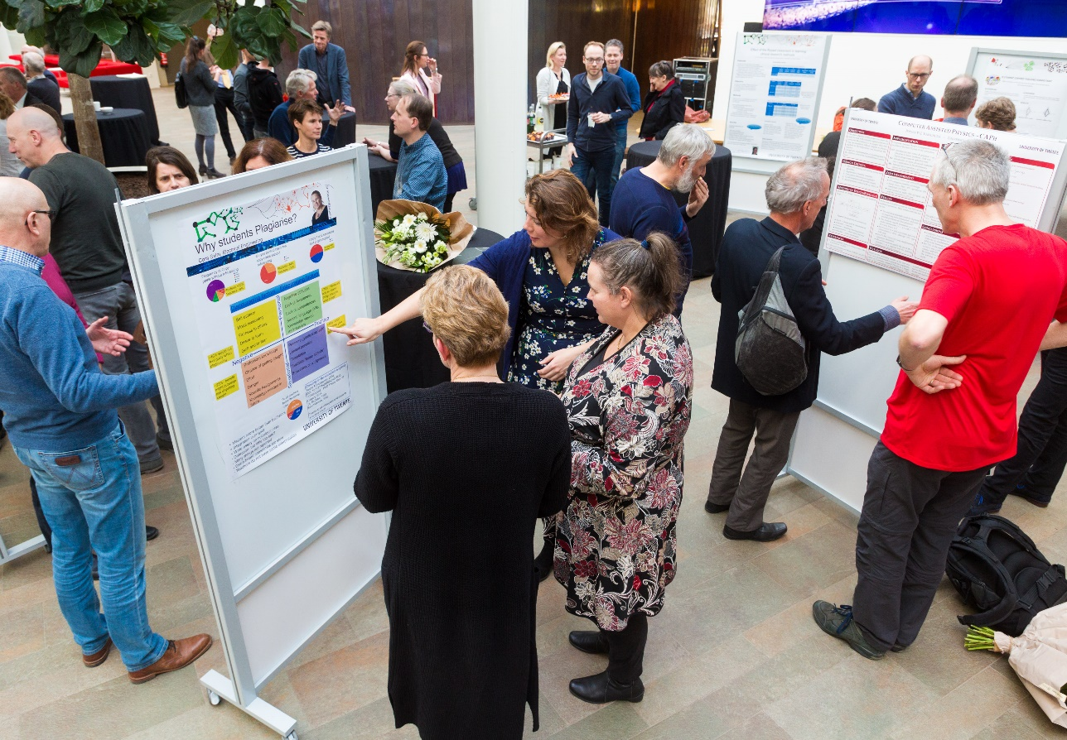

Conclusion and discussion
In the third year of running the SUTQ program, the content and approach of the program itself are largely to the satisfaction of the participants and organizers. Alignment of the intake phase, the kick-off meeting and the subsequent seminars could still be improved, however. In relation, the issue of defining a clear problem, supported by an analysis of the context and student need, also based on data, still requires more attention. Furthermore, although participants have mentioned the importance of peer interaction feedback in each of the cohorts, and we have adapted the third year approach to cater for this even more extensively, we still think the community aspect of the RLCs and the group as a whole needs improvement. And thirdly, allocation of time is still mentioned as a difficult aspect.

These challenges also need to be considered from the policy perspective. Teachers need to be supported in their professional development aimed at achieving the ambitious goals of student-driven engineering education. At the same time, recognizing and rewarding teaching is essential to support effective professional development. The SUTQ program is in its third year and participants are very enthusiastic and have shown impact on their thinking, teaching approach and students. Policy and practice for recognizing and rewarding teaching is still lagging behind, however. At the university level, it is important that recognizing and rewarding teaching is formally organized and practically realizable. Decisions have been made but not yet implemented. This needs to be an active (and interactive) process at the different management levels [7]. Specifically, at the department level as well, attention for facilitation in time and resources to participate in SUTQ, and other professional development activities focused on research-informed teaching practice still need attention. This also applies to developing a teaching community. This is partly due to the fact that staff is organized in research capacity groups. To support teachers to participate given their busy teaching schedule, for example, the seminars are scheduled from late afternoon, including dinner and the evening after dinner. Participants value being offered dinner very much, yet the question is, how much active participation can be expected in the evening after a full teaching day? And even in this situation, teachers sometimes do not have the opportunity to participate because of teaching obligations. We are expecting senior teachers to develop themselves in terms of researching and designing their own teaching, while they have a high (teaching) workload at the same time. If we really believe SUTQ has priority, should participants not have the opportunity to spend time on it during normal working hours rather than mostly in extra time? This is a difficult discussion, but one worth having if we aim to take the innovation of engineering education in a research-informed way to the next level.

ACKNOWLEDGMENTS
We would like to thank all SUTQ participants for their enthusiastic participation and valuable input and suggestions for the program. We would also like to thank Nikos Basbas for evaluating the program for his thesis and providing valuable insights for improvement.

References

- Graham, R. (2018). The Career Framework for university teaching: background and overview. Royal Academy of Engineering, London.

- Van Veen, K., Zwart, R., Meirink, J. & Verloop, N. (2010). Professionele ontwikkeling van leraren. Een reviewstudie naar effectieve kenmerken van professionaliseringsinterventies van leraren.

- University of Twente. Senior University Teaching Qualification Projects of 2017-2018 Enschede: University of Twente.

- Van der Veen, J. T., Hahnen-Florijn, M. E., Poortman, C. L., Schildkamp, K. & McKenney, S. (2017). Senior university teaching qualification via engineering education research and design. In 45th SEFI Annual Conference 2017.

- University of Twente. Senior University Teaching Qualification Projects of 2018-2019. Enschede: University of Twente

- Basbas, N. (2019). Formative Evaluation of an Advanced Professional Development Programme for University Teachers. University of Twente: Master's thesis.

- Brown, C. (2019) Using Research Learning Networks to improve higher education teaching and learning, invited talk to the ELAN Teacher Development department, University of Twente (Netherlands), 2 May, 2019.

- Graham, R. (2019). Improving University Reward for Teaching. A roadmap for change. Retrieved 20-04-2020 at https://www.4tu.nl/cee/en/publications/roadmap-for-change-web-version.pdf.

